**Prework Overview:**

The prework phase marks the initial stage of this program, ensuring that the training effectively caters to each student's specific needs and concerns. This guide provides an overview of the essential software required for download before the commencement of the course, along with other pertinent information crucial for a smooth start. Additionally, it offers a high-level preview of the course content and preliminary activities to kickstart your journey.

**Modules Overview:**

During the upcoming modules, you will:

* **Review Course Overview:** Familiarize yourself with the course structure, objectives, and expectations.
* **Verify Hardware Compatibility:** Ensure that your computer hardware meets the requirements for running the course software and tools effectively.
* **Download Necessary Software:** Download all the required software in preparation for the course commencement.

As you delve into the boot camp, anticipate a fast-paced and challenging learning environment. To ensure you're fully equipped on day one, please review the materials list and download all essential software as outlined.

Should you have any queries or require assistance, feel free to reach out to your instructors.

**Windows Installation Guide**

If you are using a Windows computer, use the following guide to install the required tools and software for this course.

**Classroom Tools**

First, we will download the following classroom tools:

* Google Chrome
* Microsoft Teams
* Zoom
* LastPass

### **Google Chrome**

If you don’t already have Chrome installed, visit the download page [here](https://www.google.com/chrome/browser/desktop/index.html). Download, open, and run the installation file.

While you're at it, you should go ahead and create a Google account, if you don't have one already, by following these steps.

1. Go to the [sign-up page](https://accounts.google.com/SignUp?) and complete the form.
2. Review and accept Google's Privacy Policy.
3. Verify you are logged in by browsing to google.com and looking for a personalized icon in the top right corner, as seen in the image below:

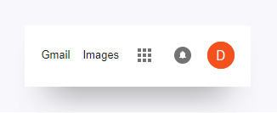

1. Click the grid icon to reveal the menu of Google services available to you, including Google Drive.

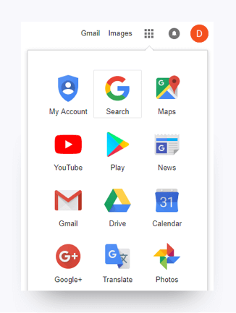

### **Teams**

1. **Note:** You will receive the link to the Teams channel during orientation.
2. Find Teams in the App Store and click **Install.**
3. From the Teams download page, under Mac, click Download.
4. Double click the PKG file.
5. Follow the installation wizard to complete the installation.
6. Teams will be installed to /Applications folder. It is a machine-wide installation.
7. Enter your email address (the one we used to invite you) and password to sign in.

### **Zoom**

1. Go to [Zoom](https://www.zoom.us/download).
2. Click the **Download** button.
3. Save the file.
4. Launch the downloaded file and that will install Zoom for you.

### **LastPass**

1. You will first need to sign up for [LastPass](https://lastpass.com/create-account.php). Once you have a LastPass account, you can download the browser extension [here](https://lastpass.com/misc_download2.php?&gclid=EAIaIQobChMI_cv-meLp6AIViT2tBh28QAX7EAAYASABEgJLvPD_BwE). Select your browser, and install!

## **Program Tools**

Next, download the following technical tools:

* Git Bash (Windows only)
* VirtualBox
* Vagrant

### **Git and Git Bash**

* Go to the Git [Downloads](https://git-scm.com/downloads) page. Select the download for Windows.

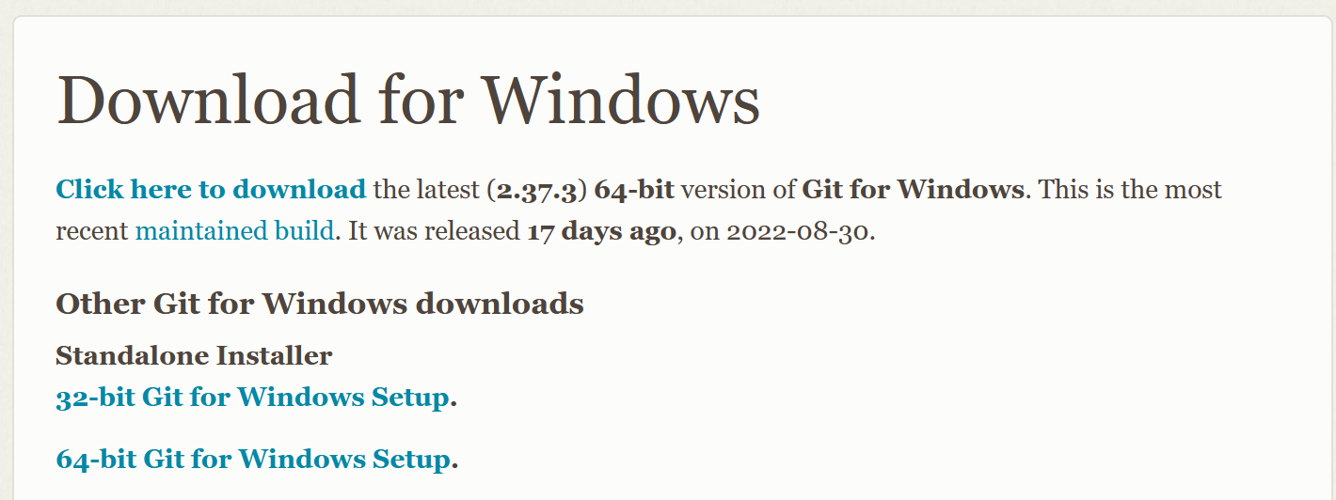

* Run the installation file. Be sure to check off the correct boxes, as shown in the following four images.
* Save Git to the desktop. This should save Git Bash to your desktop as well.

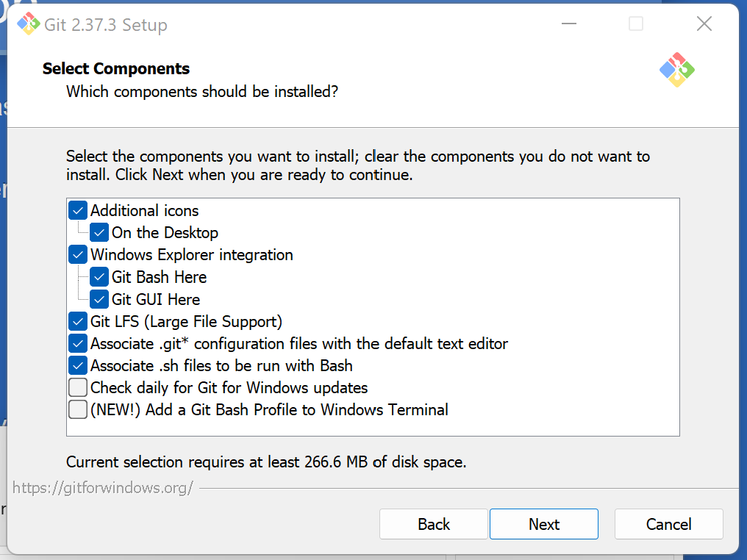

* We can leave the default editor set as **Use Vim**

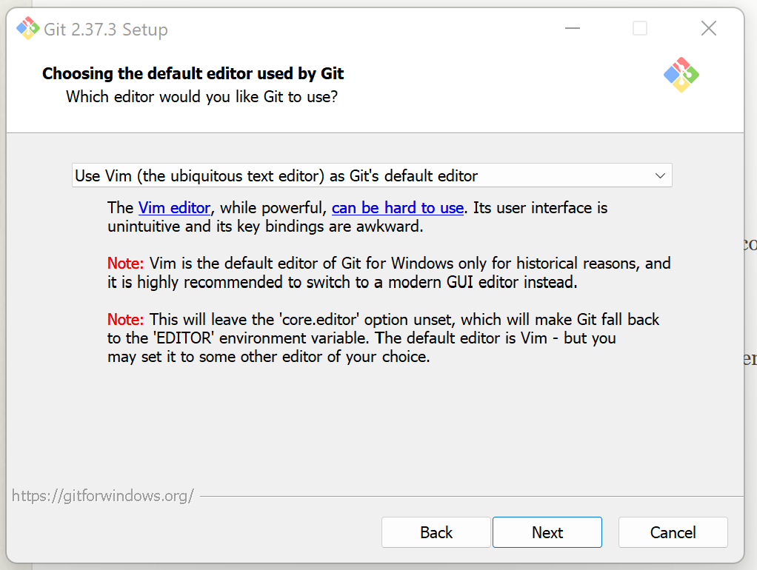

* Select **Let Git decide**

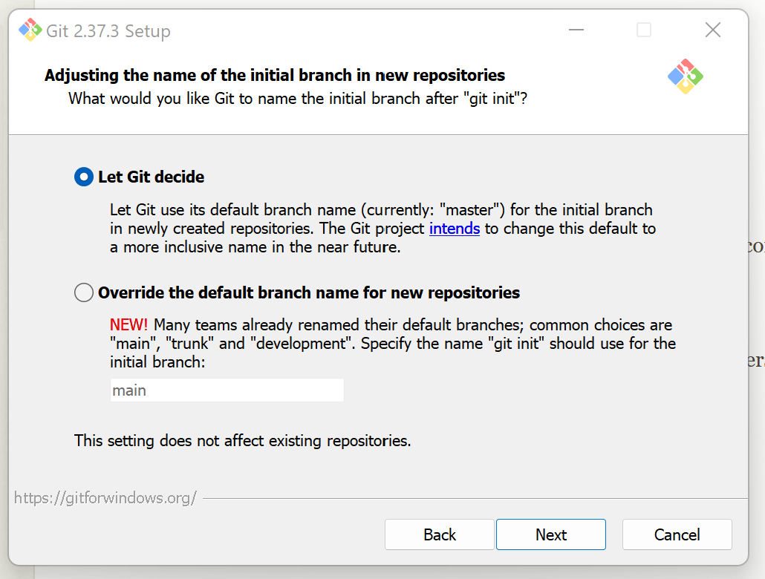

* Select **Git from the command line and also from 3rd party software**

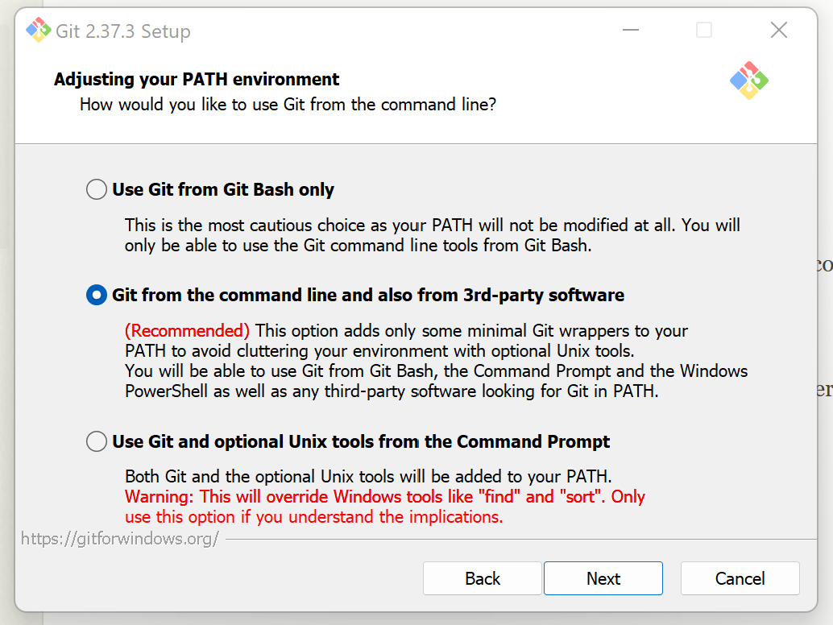

* Select **Use bundled OpenSSH**

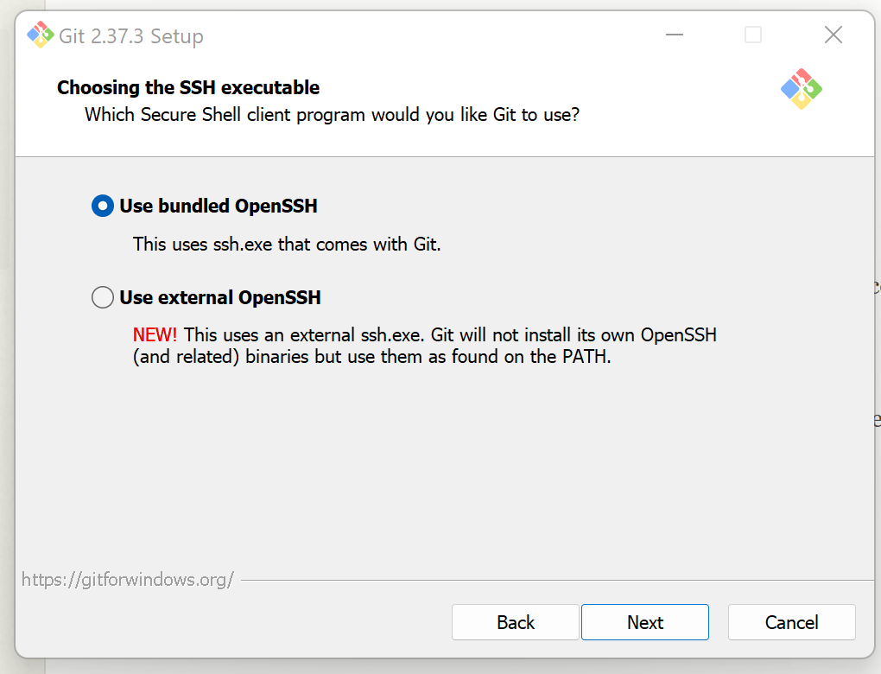

* Select **Use the OpenSSL library**

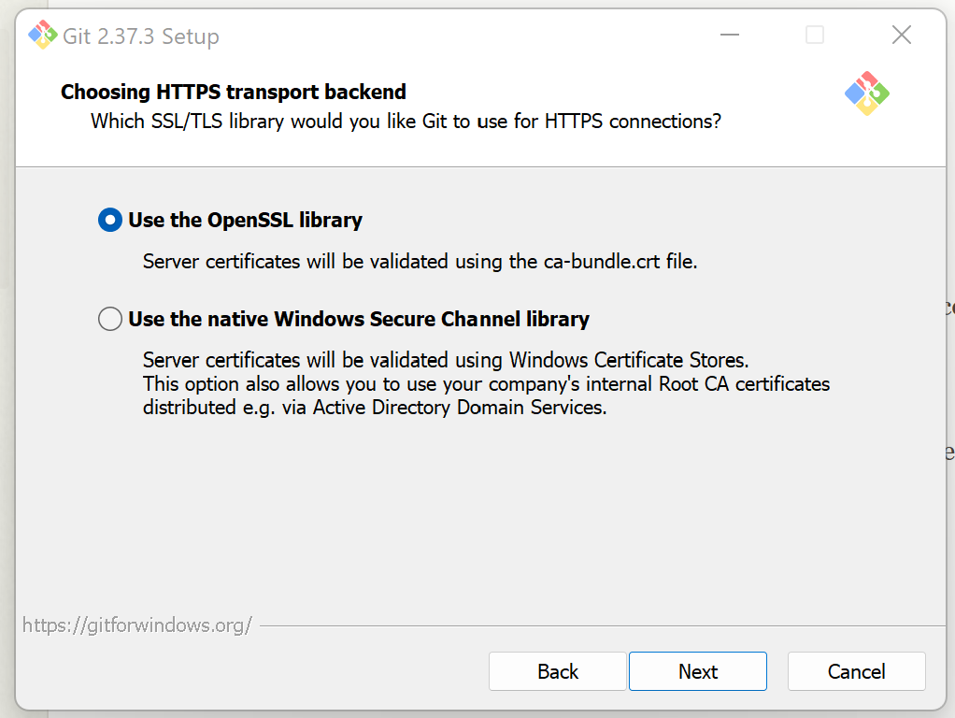

* Select **Checkout as-is, commit Unix-style line endings**

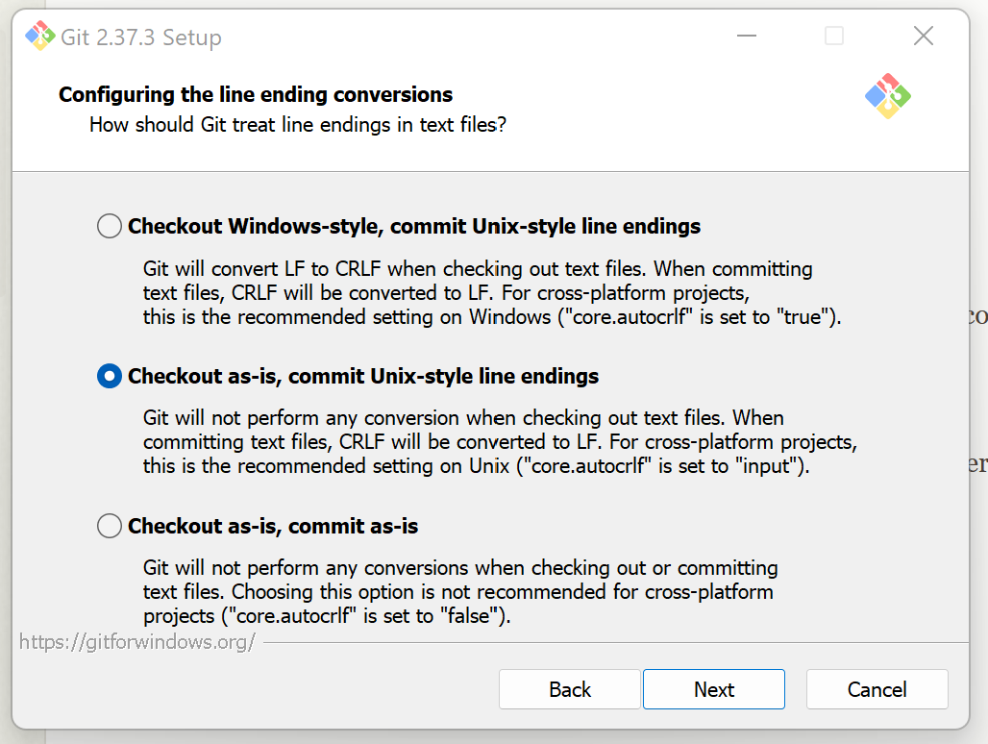

* Select **Use Windows' default console window**

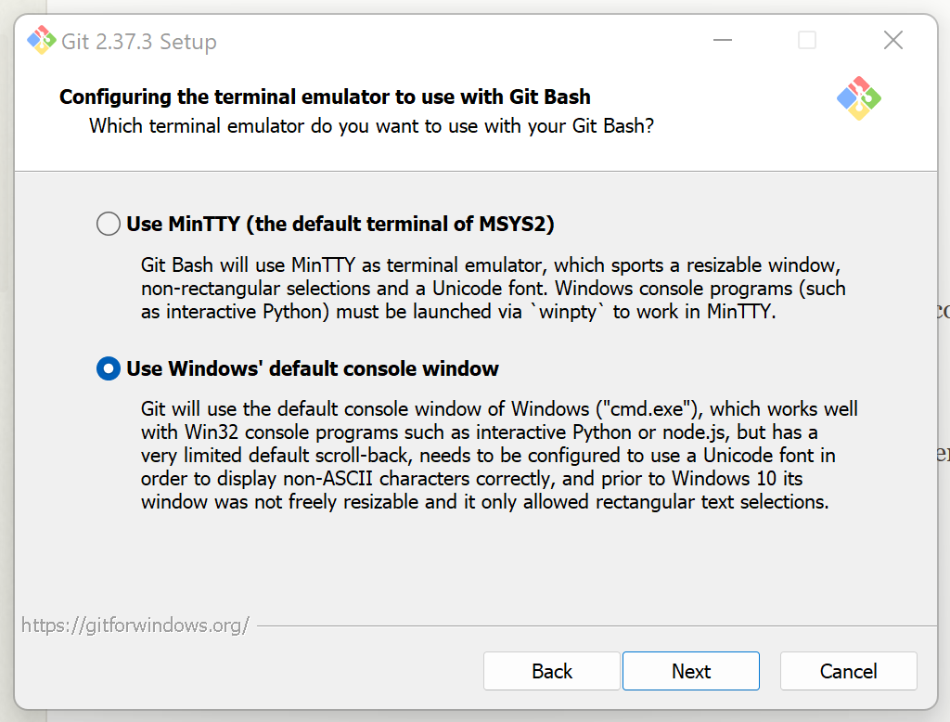

* Select **Default (fast-forward or merge)**

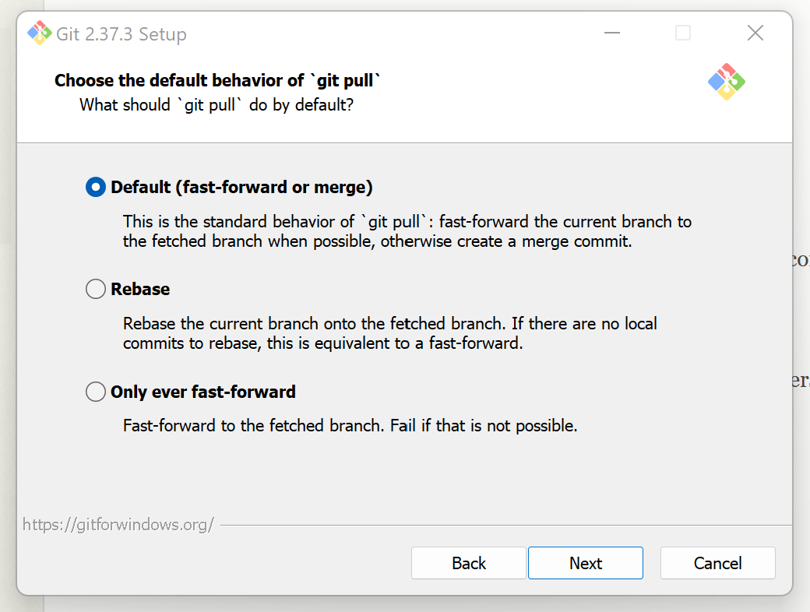

* Select **Git Credential Manager Core**

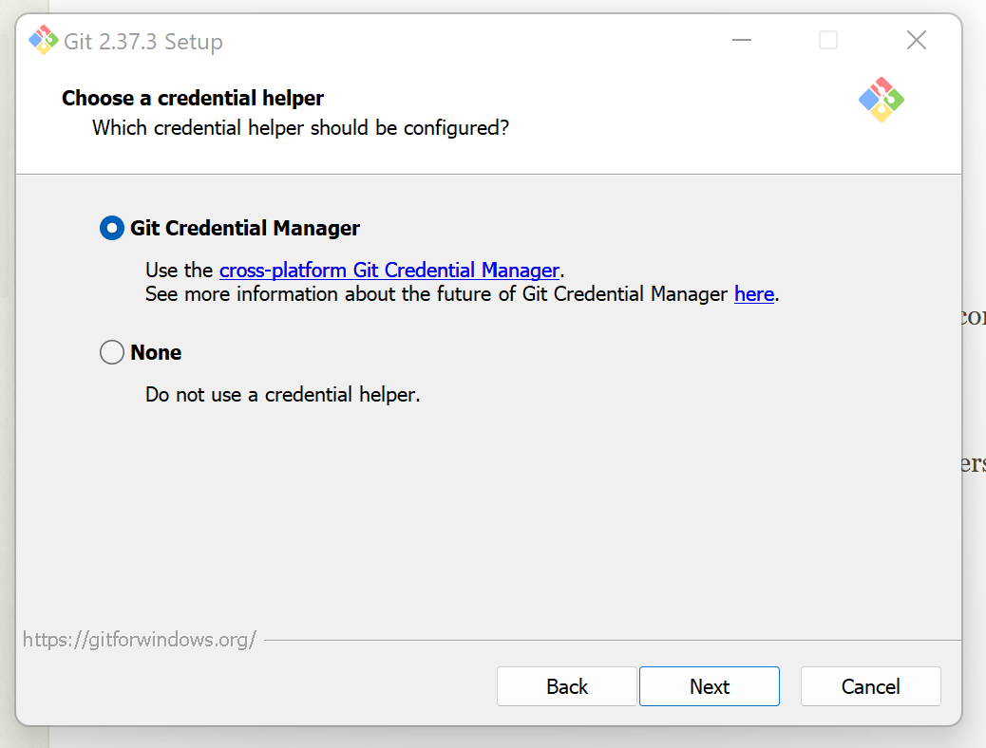

### **VIRTUALIZATION ENVIRONMENT**

### **VirtualBox**

1. Go to the [Virtual Box download page](https://www.virtualbox.org/wiki/Download_Old_Builds_6_0).

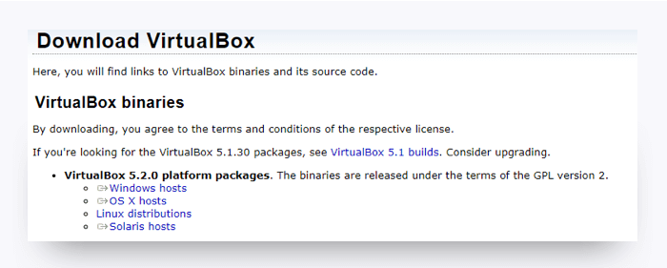

1. Select the download for Windows from the platform packages list. The latest version on this page will work.
2. When the download is complete, go to your Downloads folder and click the VirtualBox file (.exe or .dmg) to initiate the installation.
3. Follow the default installation steps. You may get a warning that you will be temporarily disconnected from the network.
4. When the installation is complete, launch the application. If you see this screen, the installation was successful.

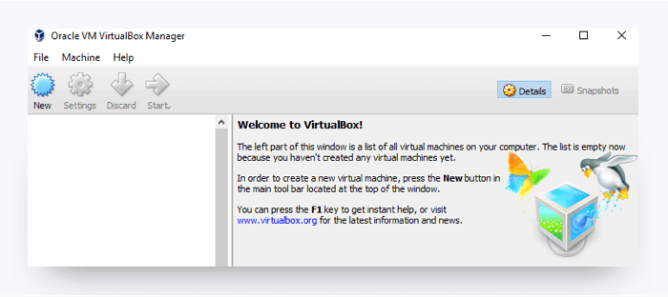

### **Vagrant**

1. Download and install the latest version of [Vagrant](https://www.vagrantup.com/downloads.html).
2. Select the appropriate installer for your operating system.
3. The installer should save to your ~/Downloads directory.
4. Open this folder, then double-click the installer.

## **You're Done!**

That's all for the installations, so give yourself a pat on the back! Installations are never fun, but just like taxes, you gotta do them.

Be sure to take a break before continuing with the rest of the prework.