### **Virtualization Resources**

### **VirtualBox**

1. Go to the [Virtual Box download page](https://www.virtualbox.org/wiki/Download_Old_Builds_6_0).

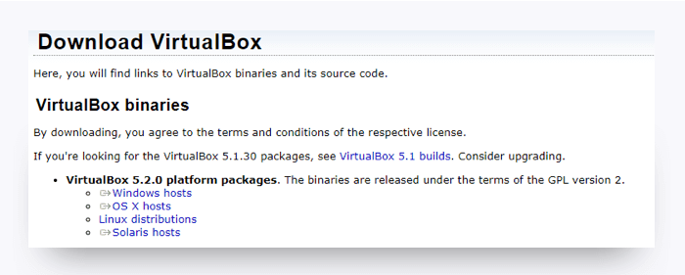

1. Select the download for Windows from the platform packages list. The latest version on this page will work.
2. When the download is complete, go to your Downloads folder and click the VirtualBox file (.exe or .dmg) to initiate the installation.
3. Follow the default installation steps. You may get a warning that you will be temporarily disconnected from the network.
4. When the installation is complete, launch the application. If you see this screen, the installation was successful.

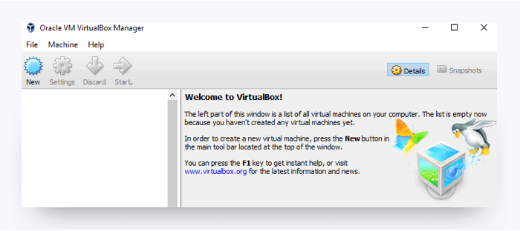

### **Vagrant**

1. Download and install the latest version of [Vagrant](https://www.vagrantup.com/downloads.html).
2. Select the appropriate installer for your operating system.
3. The installer should save to your ~/Downloads directory.
4. Open this folder, then double-click the installer.

**Ubuntu(Linux OS) on windows 10 & 11 using Virtualbox**

### 1. Download Ubuntu ISO File

So before discussing how we can install Ubuntu on Windows 10. You have to download the Ubuntu ISO file on Windows 10. For that, visit [ubuntu.com](https://ubuntu.com/download/desktop),click on the download option from the menu select Ubuntu Desktop, and download the LTS version for the Windows operating system.

Here are the recommended system requirements to install Ubuntu to your system:

* 2 GHz dual-core processor
* 4 GB system memory
* 25 GB of free hard drive space
* Internet access is helpful

### 2. Creating a Virtual Machine for Ubuntu

Now, to install Ubuntu on Windows 10 using VirtualBox, we have to create a virtual machine for that. To create a virtual machine, you can follow the steps mentioned below:

**1**. Open the **VirtualBox** software and click on the **New** icon to create a virtual machine for Ubuntu.

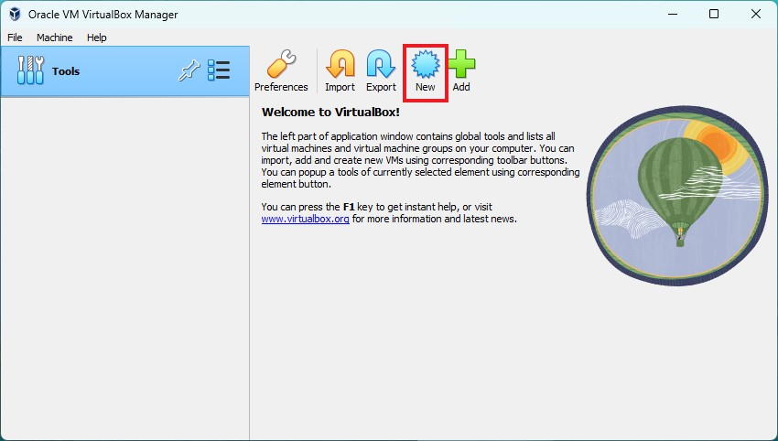

**2**. After that, name your machine, and select the type of Operating System as **Linux** and the version that you had downloaded (32-bit or 64-bit).

**3**. After selecting all this just click the **Next** button. Don’t worry we will select the ISO file later on.

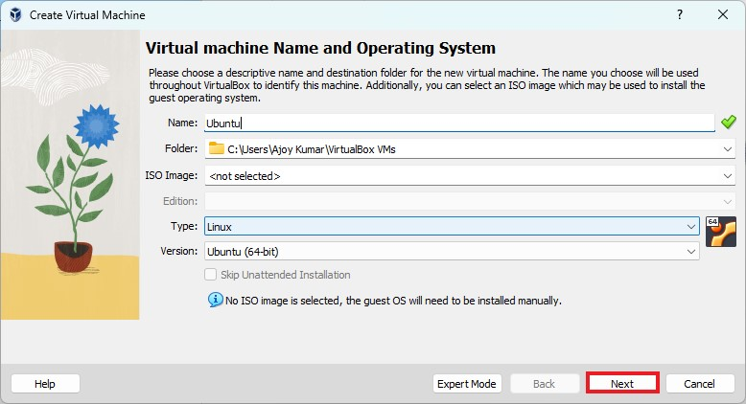

**4**. Assign the amount of RAM you want to give to your Ubuntu Virtual Machine. **4GB is the recommended one**, however, for better performance you can allow more if your host system (Windows 10) has enough spare memory block. From here, you can also assign a CPU core.

**5**. Then click on the **Next** button.

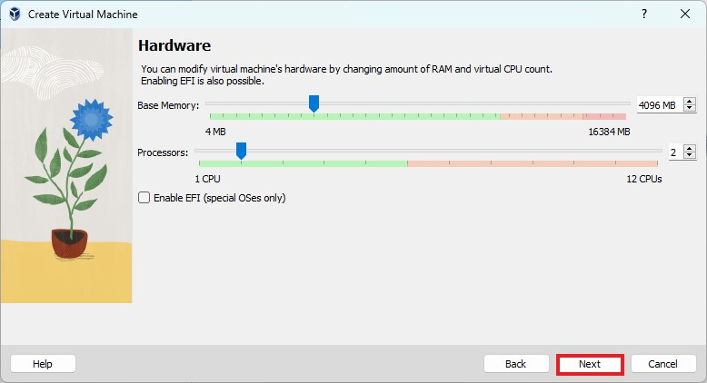

**6**. After that, you also need to allocate hard disk space. For that, click on the **Create a Virtual Hard Disk Now** option, let the default option be selected, and just click on the **Next** button. 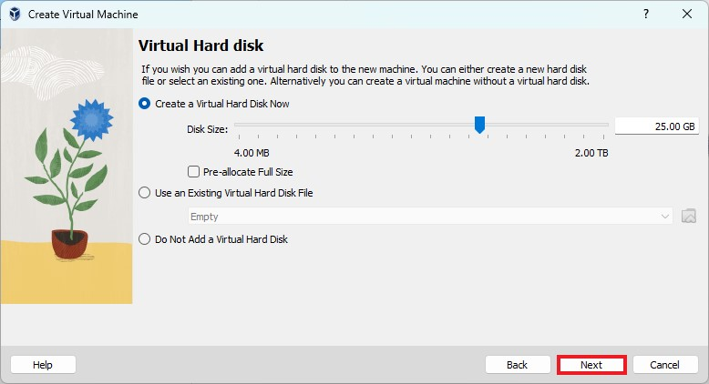

**7**. Now, review the virtual machine setup and click on the **Finish** button.

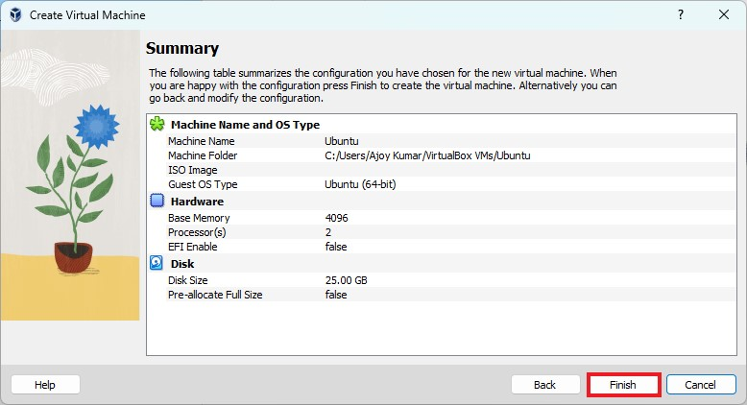

**8**. Now, you have to select the Ubuntu ISO file. For that, select the operating system name in VirtualBox, then click **Settings > Storage > Controller ID > Empty > Optical Drive**.

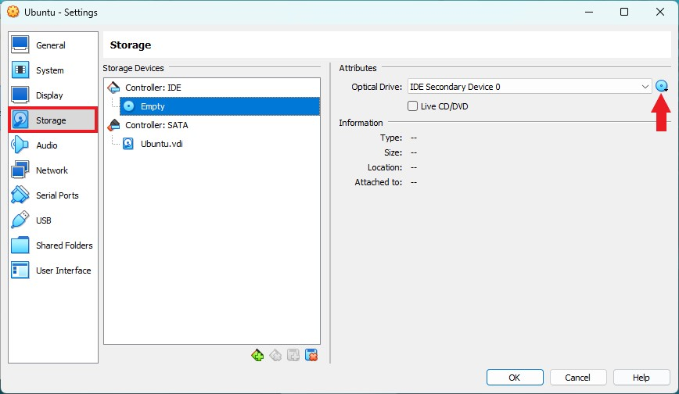

**8**. After that, click on the optical drive drop-down menu and select the **Choose disk file** option. Select the Ubuntu ISO image file from your downloaded location, then click the **OK** button.

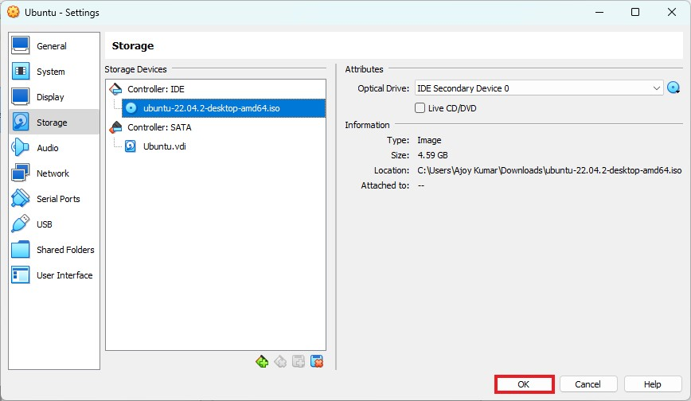

That’s it! This is how you can create a virtual machine for the Ubuntu operating system. Once the virtual machine is created, you can proceed to the next step.

### 3. Installing Ubuntu on VirtualBox

Now, our virtual machine is ready for the installation process. You can proceed with the installation and setup process of Ubuntu 22.04 LTS.

To do so, you can follow the steps mentioned below:

**1**. To install Ubuntu 22.04 LTS on a Virtual Machine, select your virtual machine name and click the **Start** button.

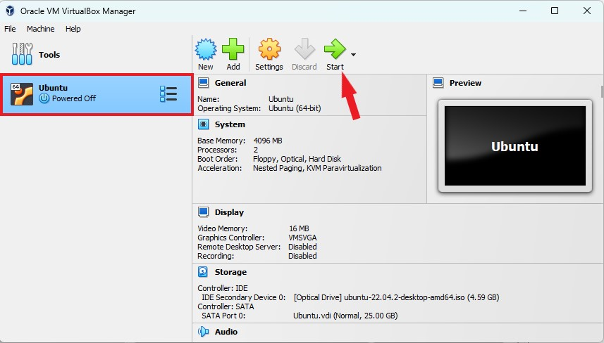

**2**. After that, you will get the GUN GRUB window. Here, select **Try or Install Ubuntu** and hit the [**Enter**] key.

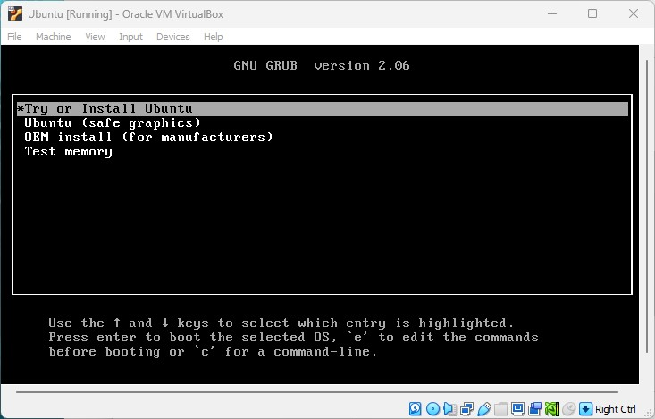

**3**. After that, it will open the Ubuntu installation window.

**4**. Here, you have to set up your Ubuntu installation. For that, select your language, and click on the **Install Ubuntu** button.

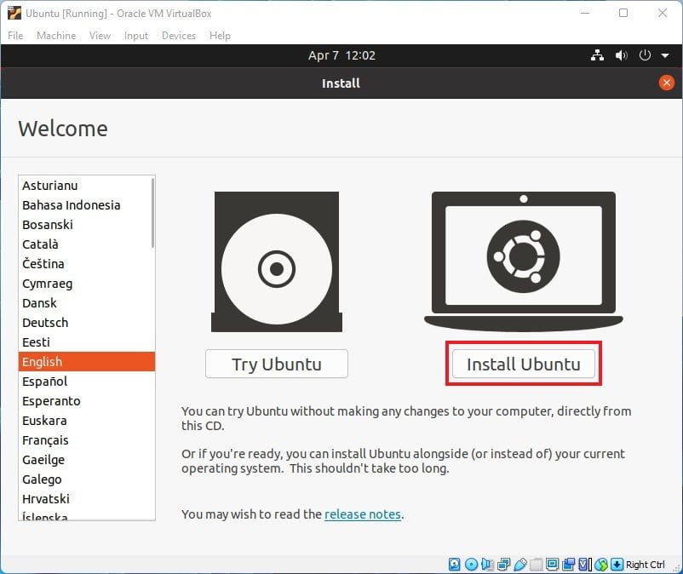

**5**. After that, select the Keyboard language and layout and then click on the **Continue** button.

**6**. On the **Updates and other software** window. You have to select the normal installation, download updates while installing Ubuntu, and Install third-party software of graphics and Wi-Fi hardware and additional media formats.

**7**. Then click on the **Continue** button.

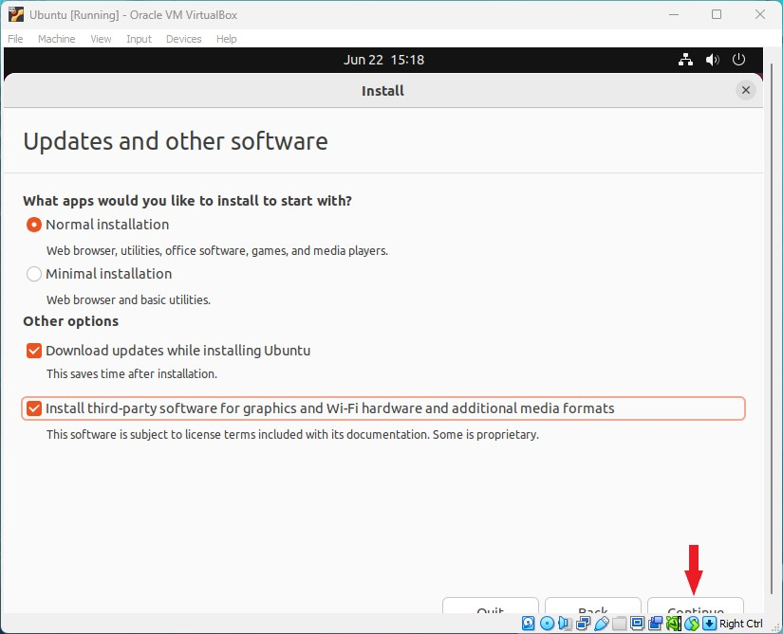

**8**. After that, select the installation type as the **Erase disk and install Ubuntu** option. Don’t worry, it will not erase any of the data because we are installing it on a virtual machine.

**9**. Finally, click on the **Install Now** button to continue.

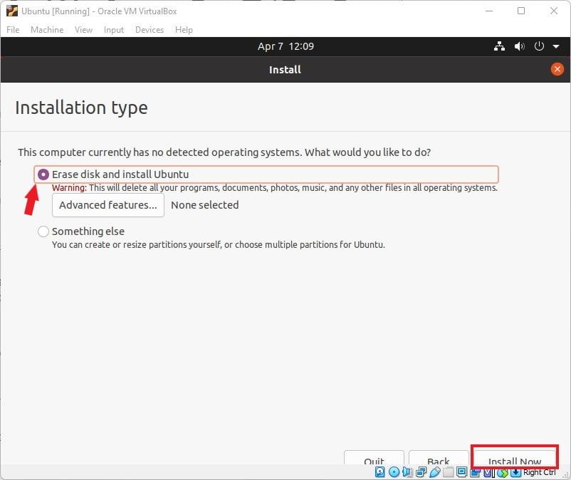

**10**. After that, click on the **Continue** button, select a location, register a user, and click on **Continue**. It will take approximately 30 minutes to install the Ubuntu operating system on VirtualBox.

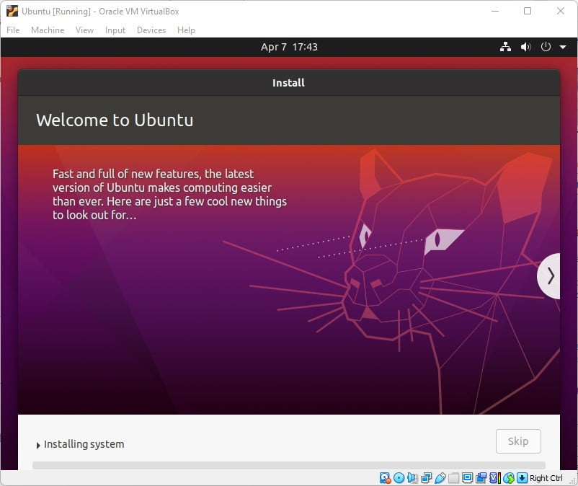

After the installation is completed restart the virtual machine, on the booting windows press the [**Enter**] to reboot. Now, you are ready to use Ubuntu 22.04 LTS on Windows 10

**Installing Windows 10 Operating System on Virtualbox**

**Step 1: Downloading Windows 10 ISO File.**

After setting up your Virtual Box, Search Microsoft Windows Evaluation 10 and download Windows 10 ISO file from microsoft.com (free trial only available for 90 days). Then fill up all the requirements and click on Continue to download it. Note that you have to register before moving to the ISO file download page as shown below.

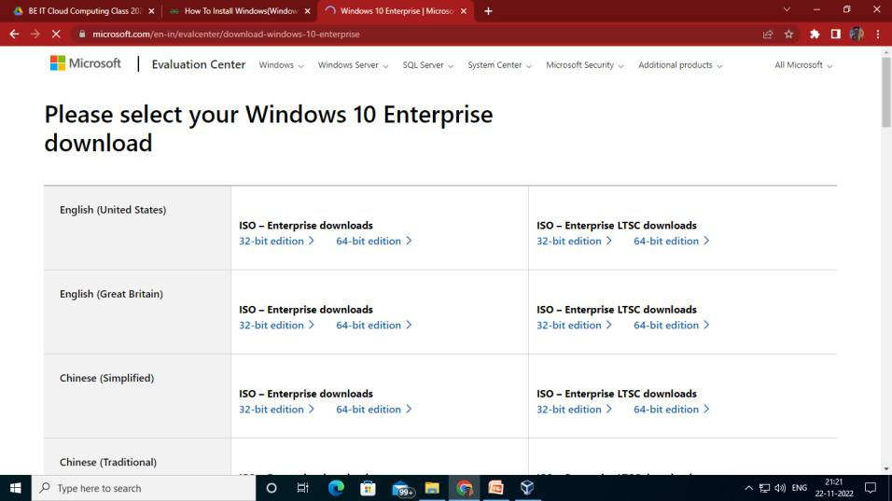

After the download has been completed, it will be stored in your Downloads folder on This Computer.

**Step 2: Installation of Windows 10 in Virtual Box.**

Start the installation of the Windows 10 operating system. Select a name, then the type as MS Windows and the version as Windows 10(64-bit) with respect to the machine used. Then provide memory according to our RAM size preferably 2-4GB and then leave the Hard disk file type as VDI, then select the virtual hard disk size, and you are done as shown below

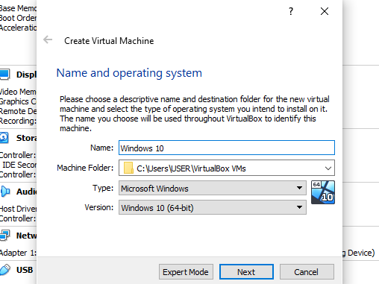

Then provide memory according to our RAM size preferably 2-4GB. We have selected here 1GB which is 1024MB for demonstration purposes but on your computer, we would prefer to allocate at least 2048MB of memory.

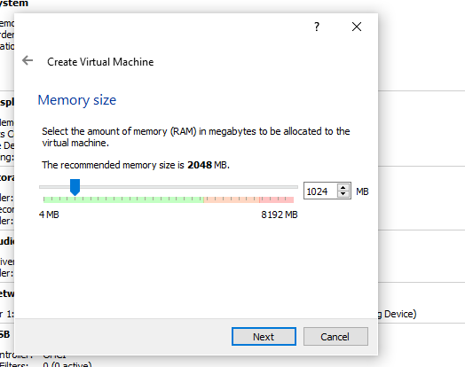

Then leave the Hard disk file type as VDI.

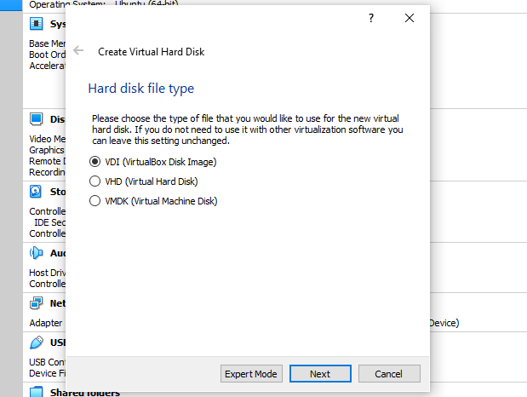

Then select the virtual hard disk size. We selected here 50GB. You can select according to your CPU space available.

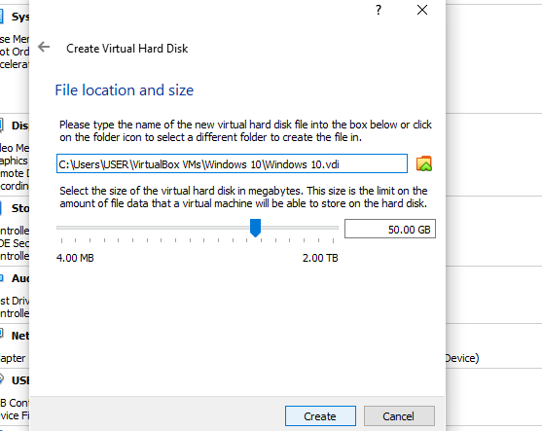

**Step 3: Sharing the Location of the ISO File of Windows 10.**

Go to **Settings->Storage->Click on “Empty” under “Controller” choose the CD icon and then click on “choose a disk file”**. Browse to the location where you have downloaded the Windows 10 ISO file. Copy the location and paste it.  
Once this is done, other settings can be changed also or can be kept default.

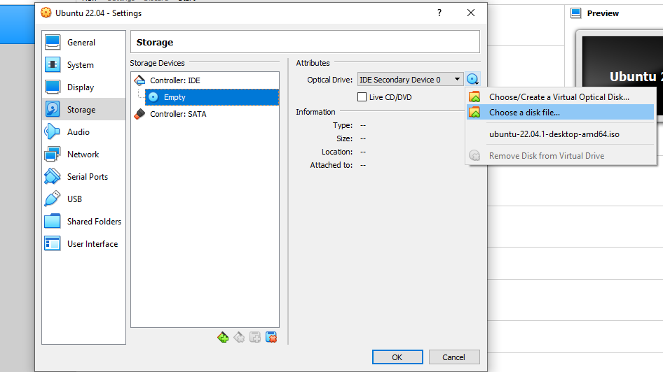

Browse to the location where you have downloaded the Windows 10 ISO file and select it so that Windows 10 gets installed on VirtualBox.

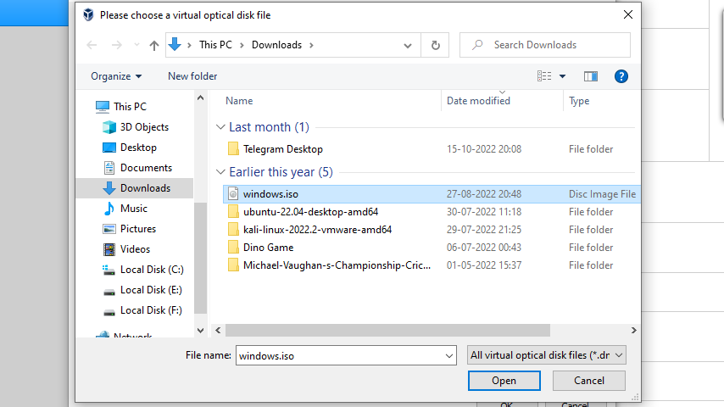

**Step 4: Running Windows on Virtual Box**

That is Windows 10 has been installed on the Virtual Machine. You can now open the Windows 10 operating system in VM. Set up a new username and password and use Windows 10 in VM for various purposes.

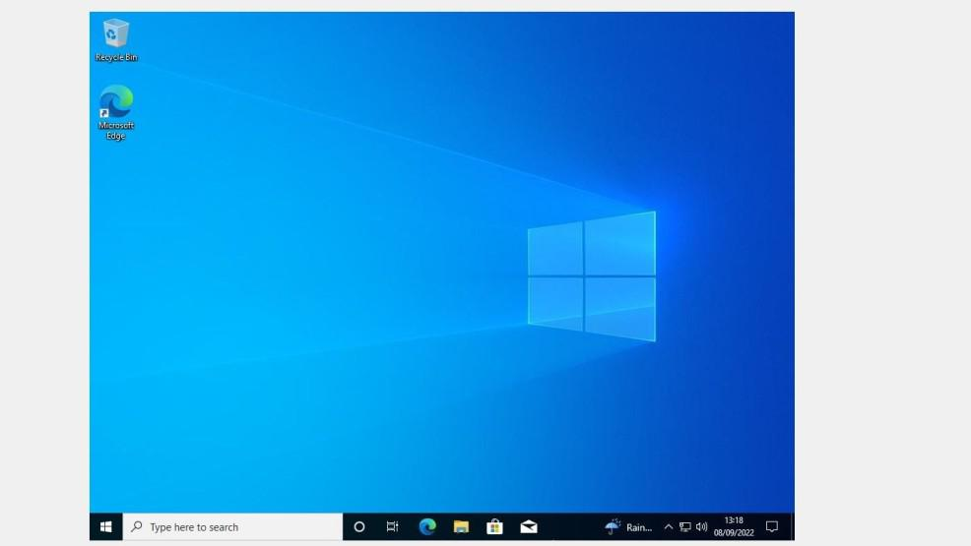

## **You're Done!**

That's all for the installations, so give yourself a pat on the back! Installations are never fun, but just like taxes, you gotta do them.

Be sure to take a break before continuing with the rest of the prework.