
Qurate User Journey

- After purchasing the course, retrieve the login details sent to your email.

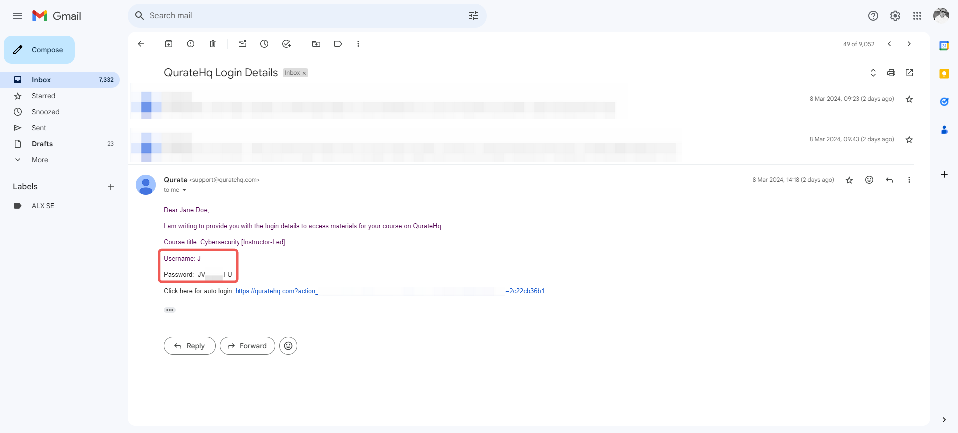

- Visit https://quratehq.com and click the Login➀ button.

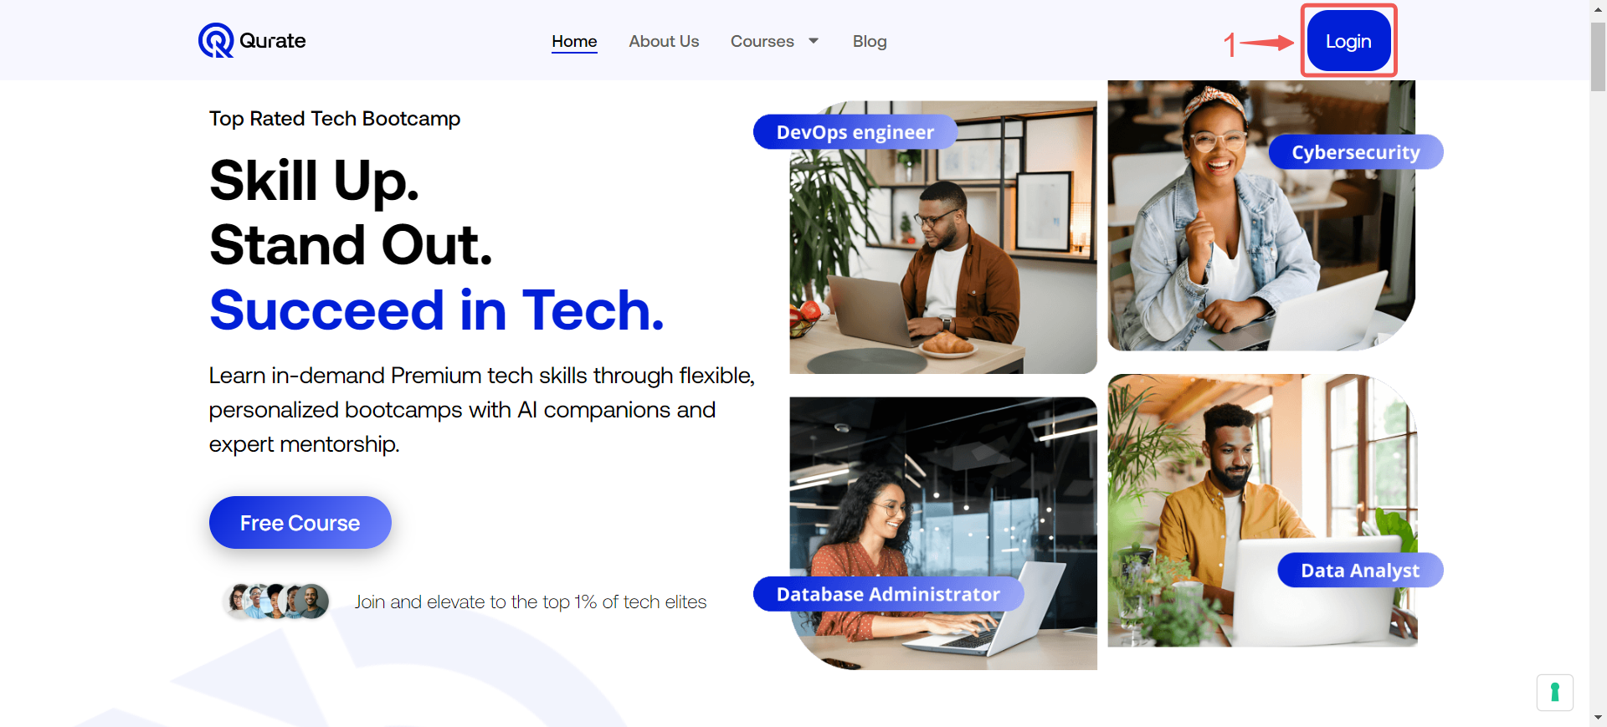

- On the Qurate login page, enter your Username➁ and Password➂ in the designated fields, If you'd like your device to remember your login credentials for future convenience, select the Remember Me➃ option, and click the Log in➄ button to proceed to your account.

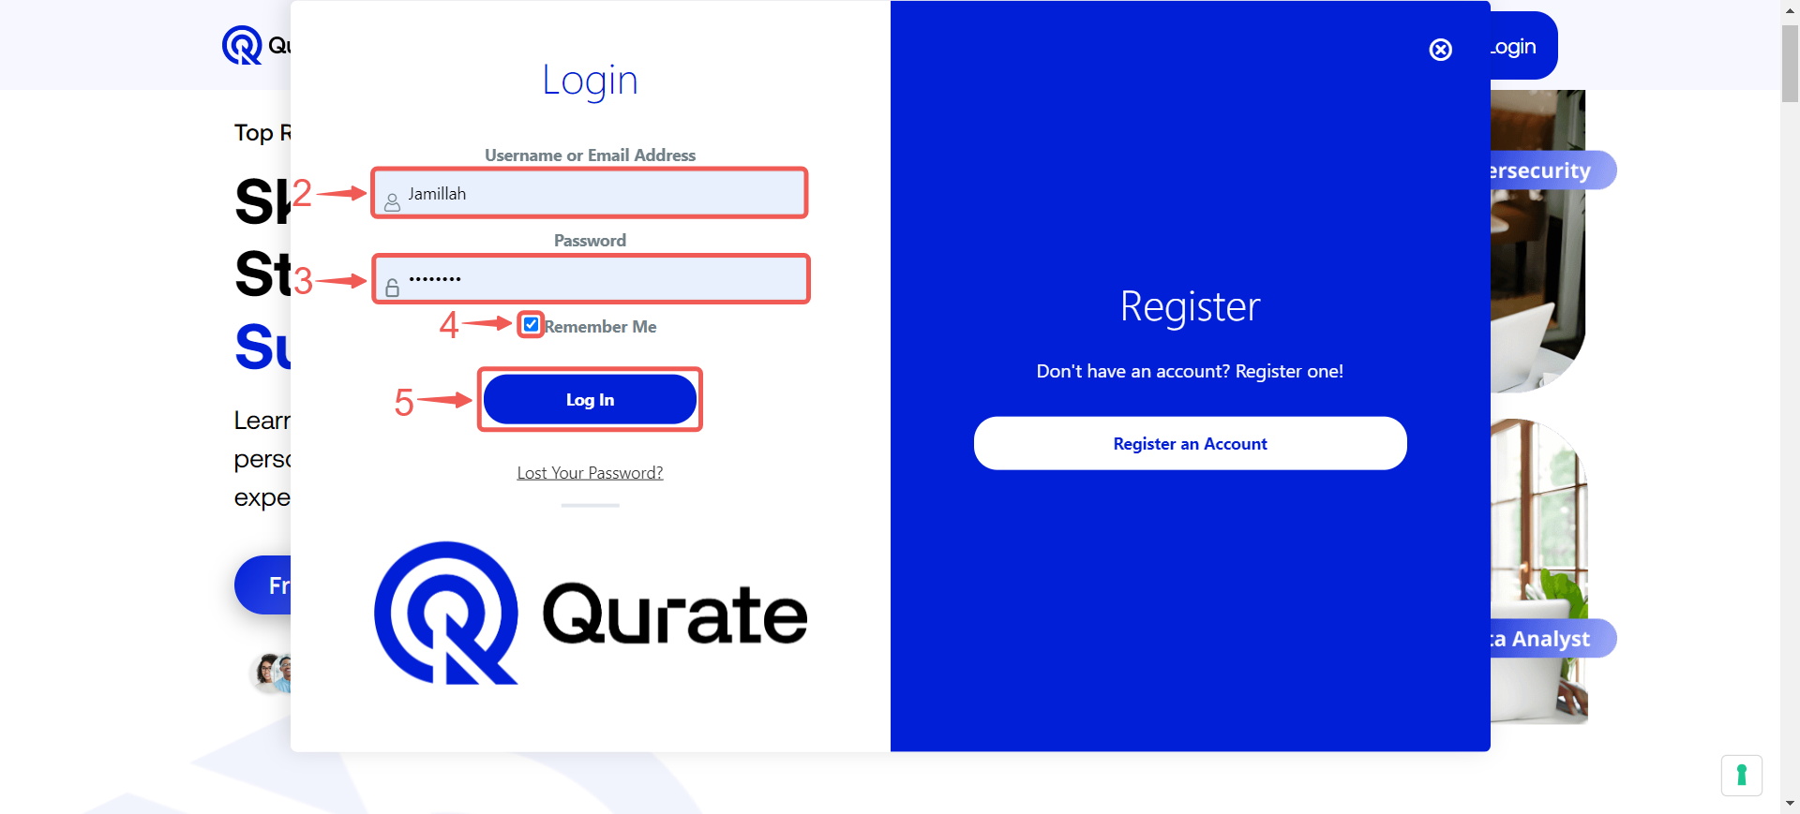

- Click My Account➅ to open your dashboard where you can view all your enrolled courses in one place

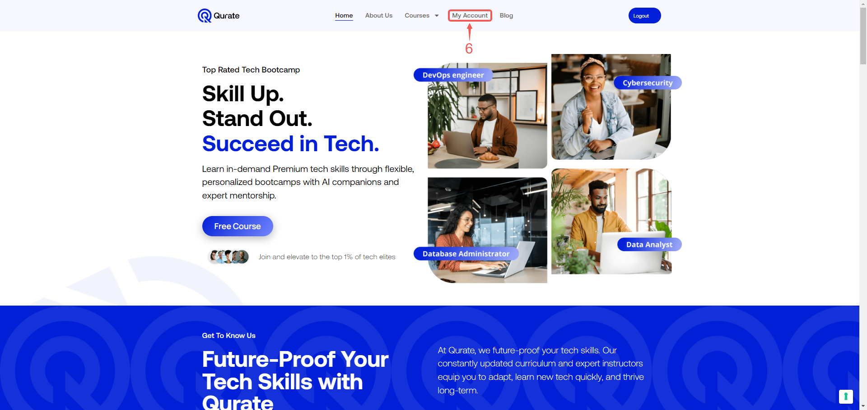

- As you enter your account, you'll see broadcast messages right away. This ensures you stay informed about critical course information and announcements from your instructor.

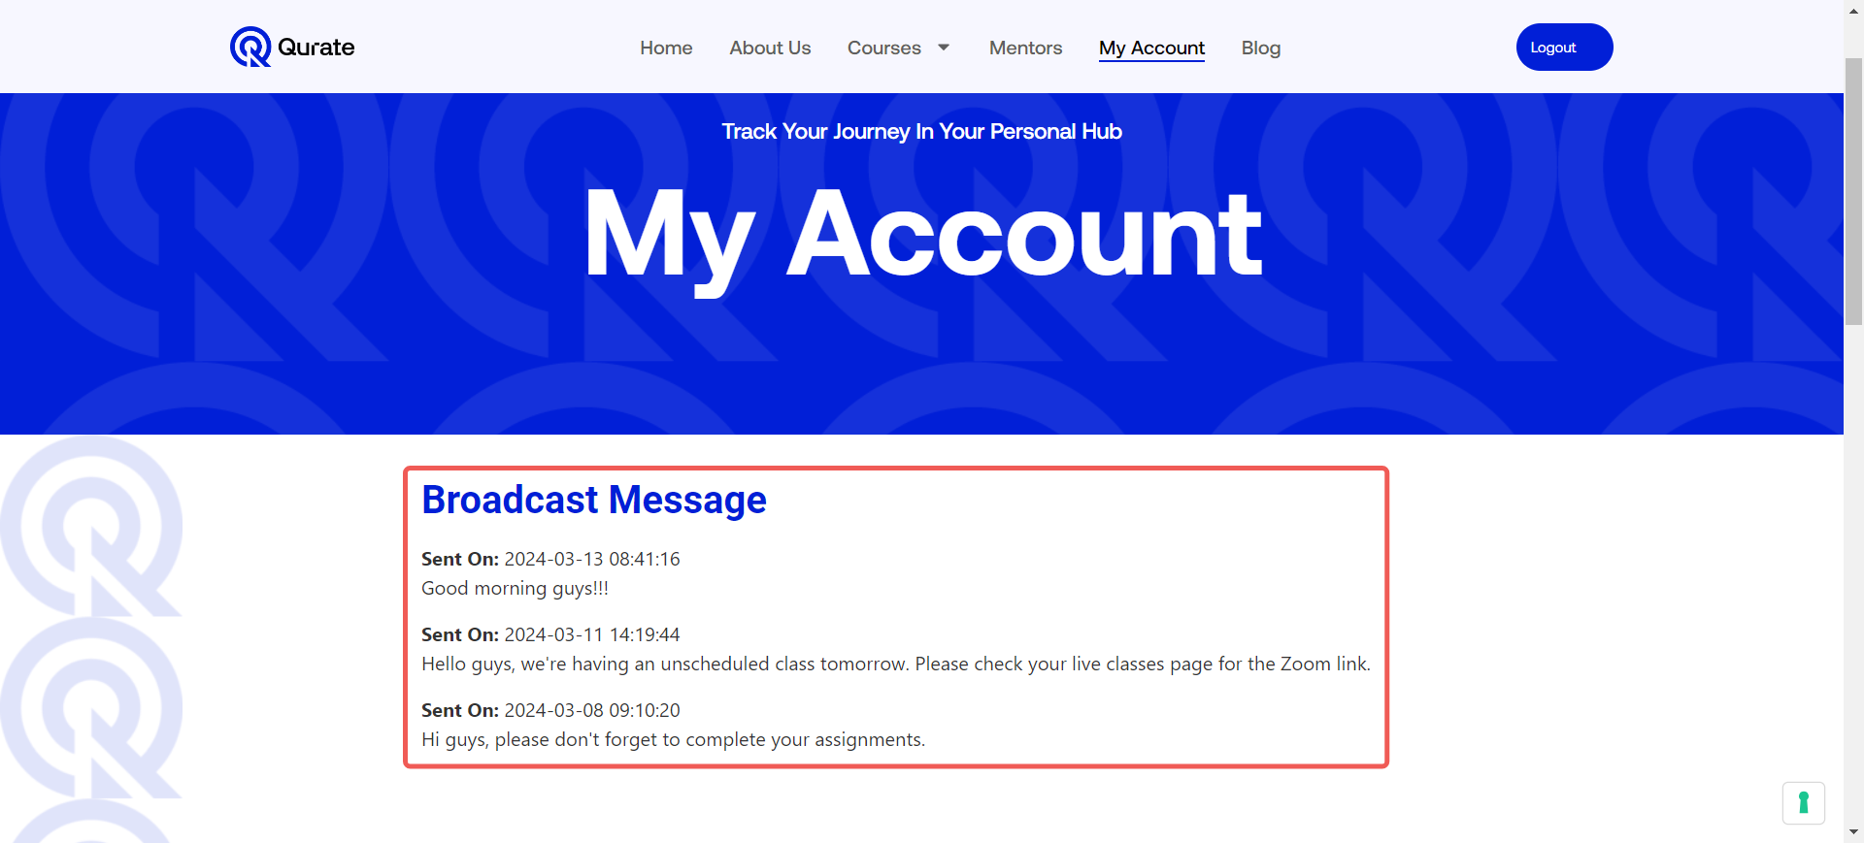

- On this page, you can find your Live-class➆, and the Course➇ you enrolled in.

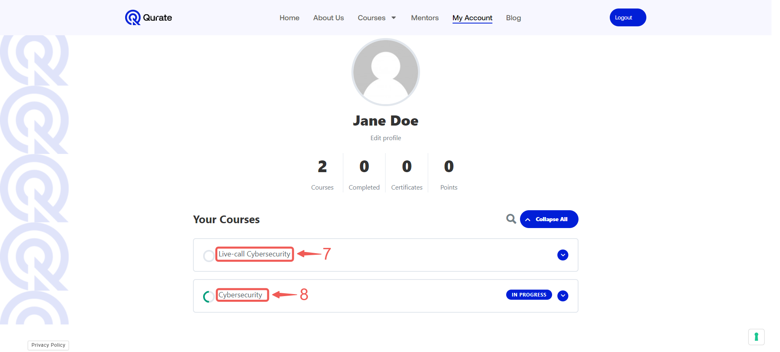

Note: I am currently enrolled in the Cybersecurity class, so my Live class is titled "Live-call Cybersecurity." The specific Live class title may vary depending on the course you are enrolled in. For example, if you are enrolled in the DevOps class, it will be titled "Live-call DevOps."

Editing Your Profile

- Click Edit profile➀.

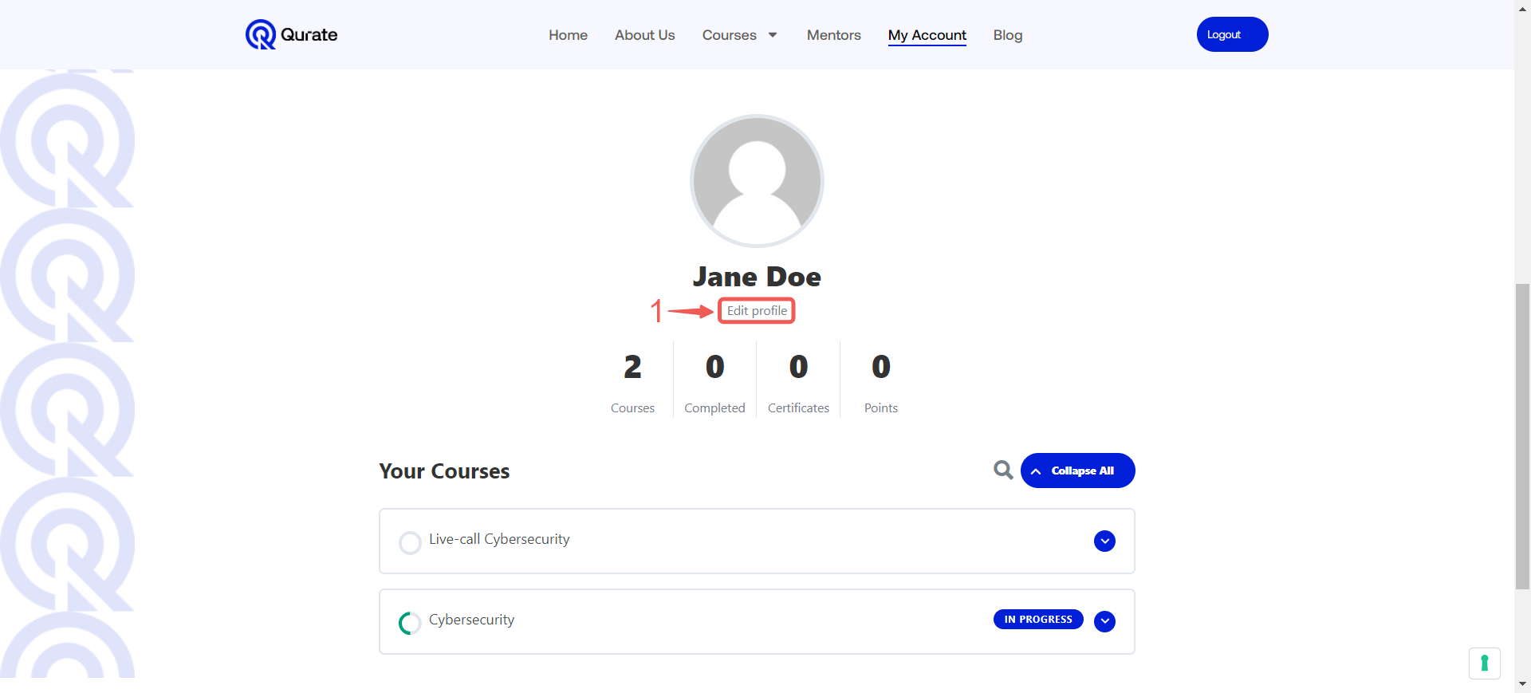

- In the Name section, you can modify your username, name, nickname, and display name as needed.

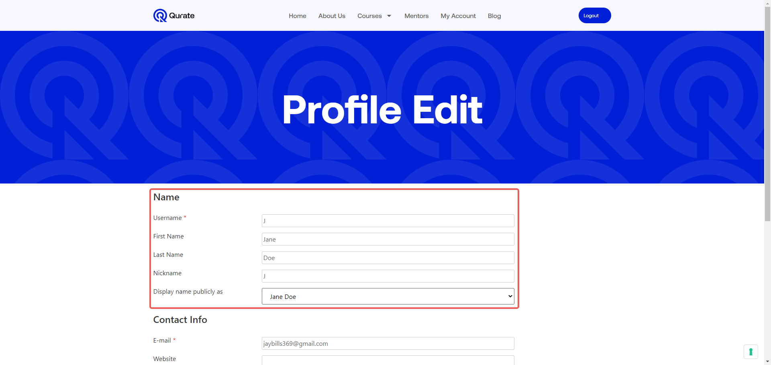

- To change the name displayed publicly on your profile, click the chevron-down icon➁ and select your preferred name➂ from the drop-down menu.

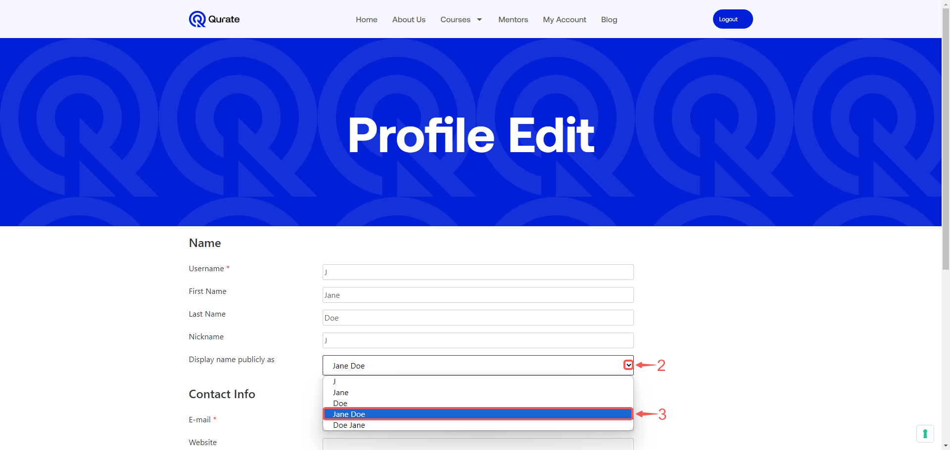

- This section gives you control over your contact information. You can update your email address to receive notifications and choose to add a link to your website for professional networking purposes.

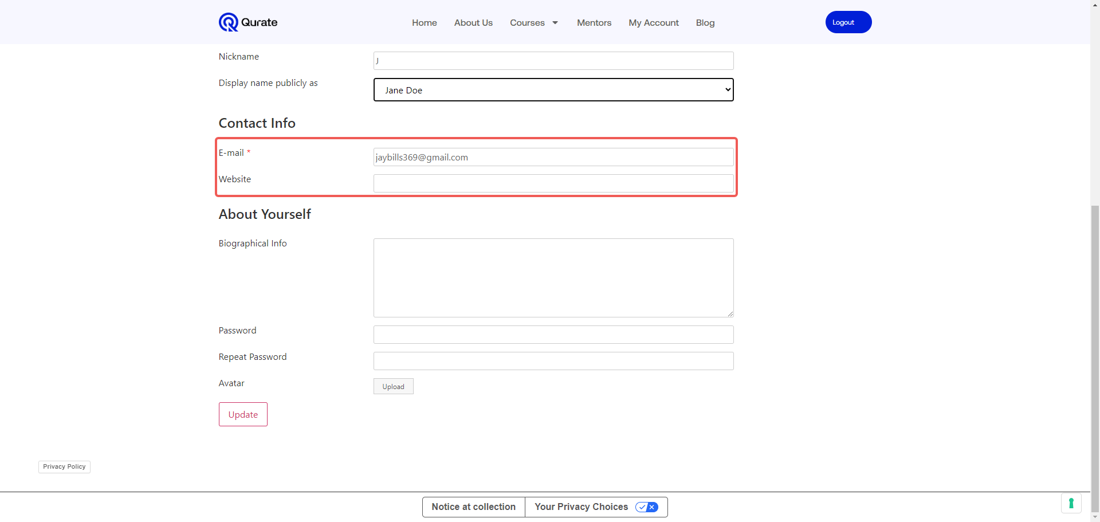

- The About Yourself section allows you to update your bio and avatar.

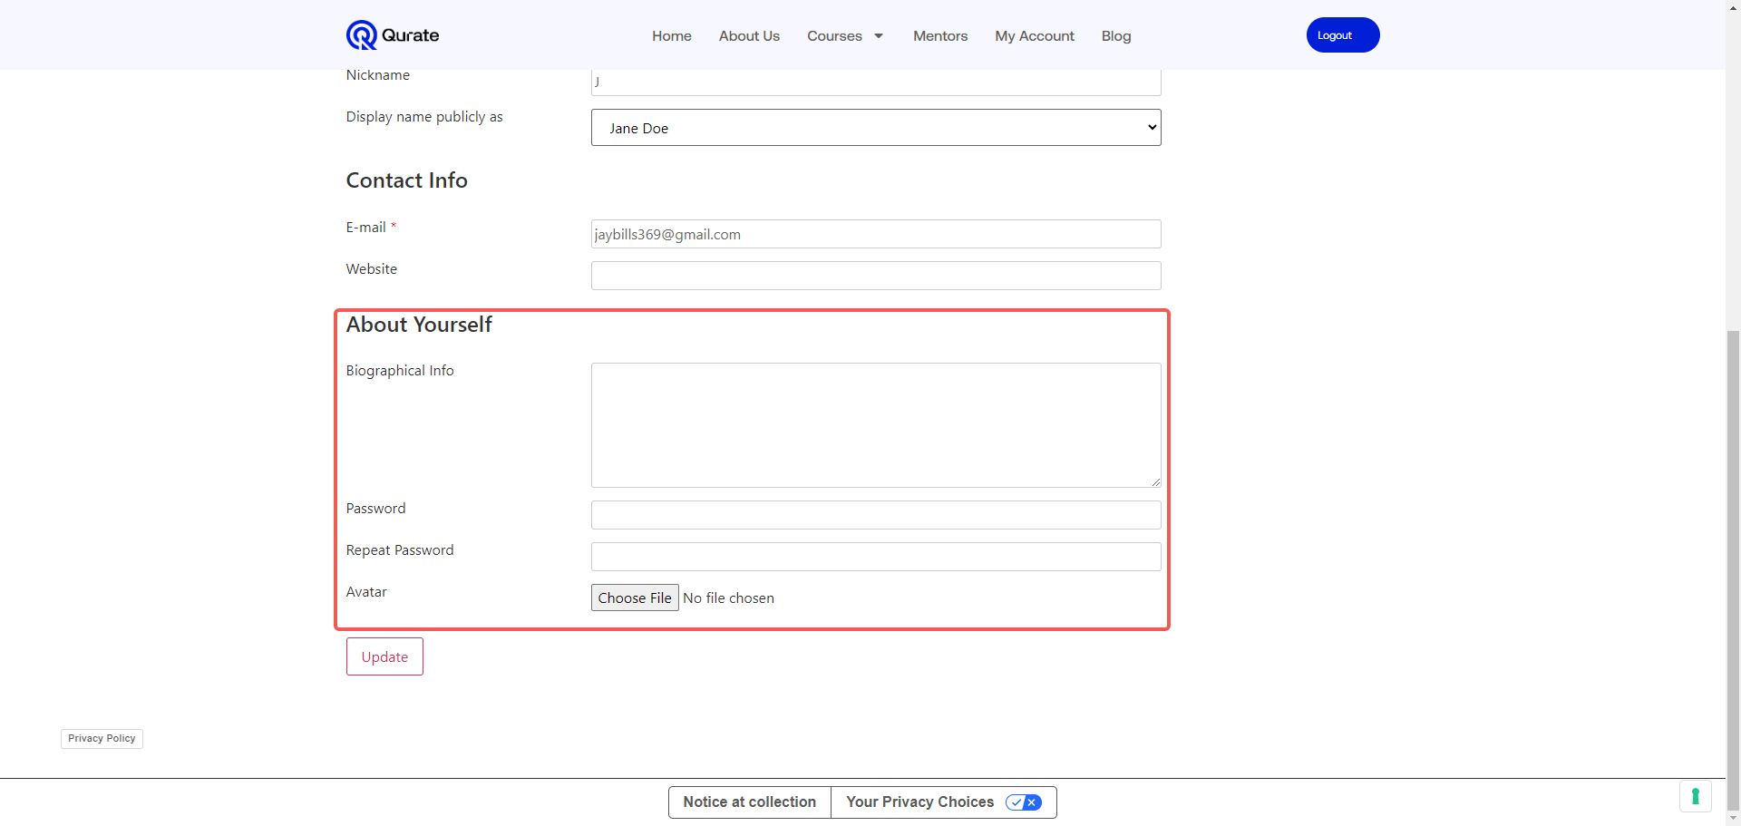

- Click Choose File➃ to browse your device and select the picture you want to set as your avatar.

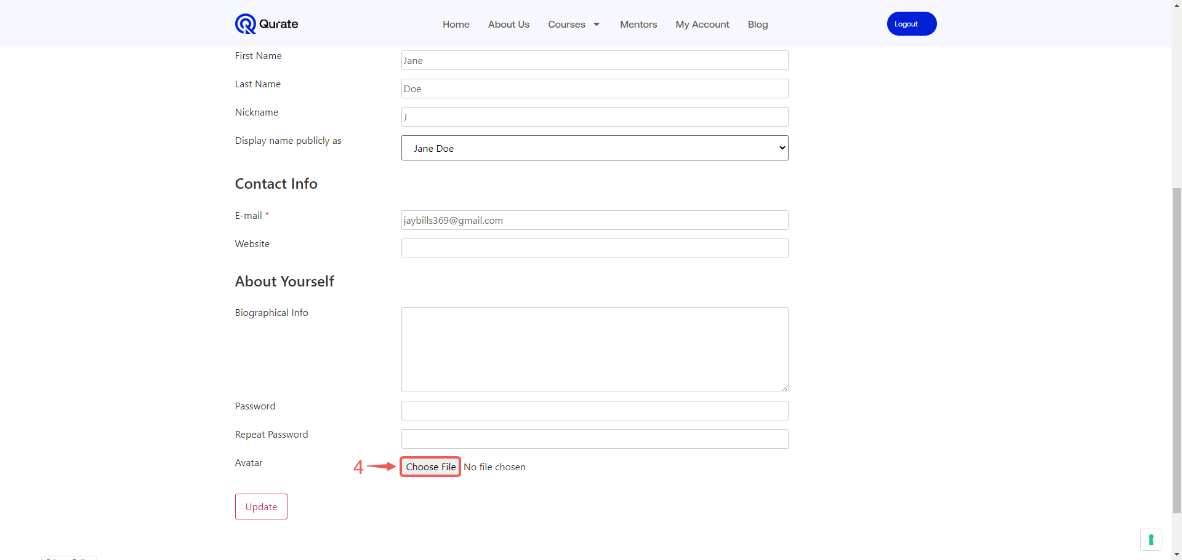

- Select the file➄ you wish to upload. Then, click the Open➅ button to submit it to the platform.

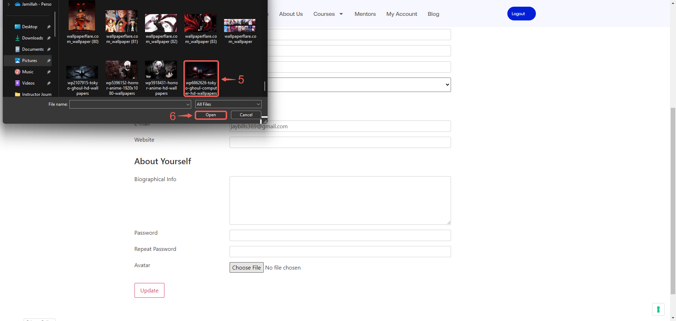

- Click the Update➆ button to save your profile modifications and ensure they are reflected on your account.

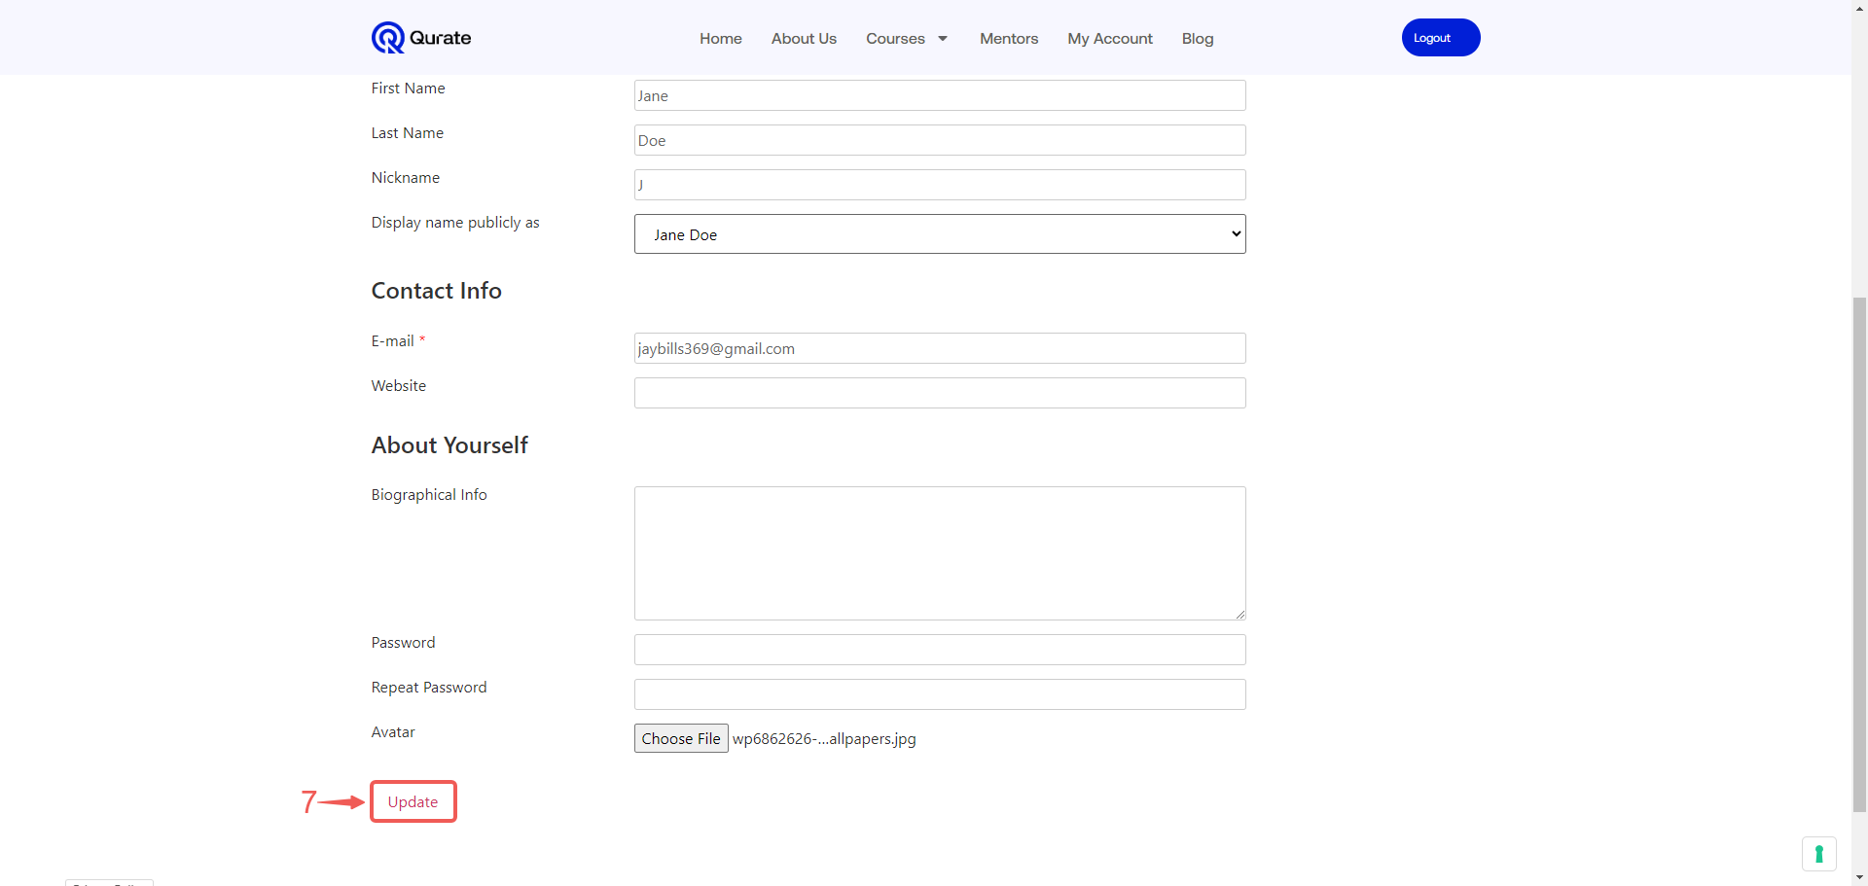

- Click My Account➇ to return to your account page and view your bio changes.

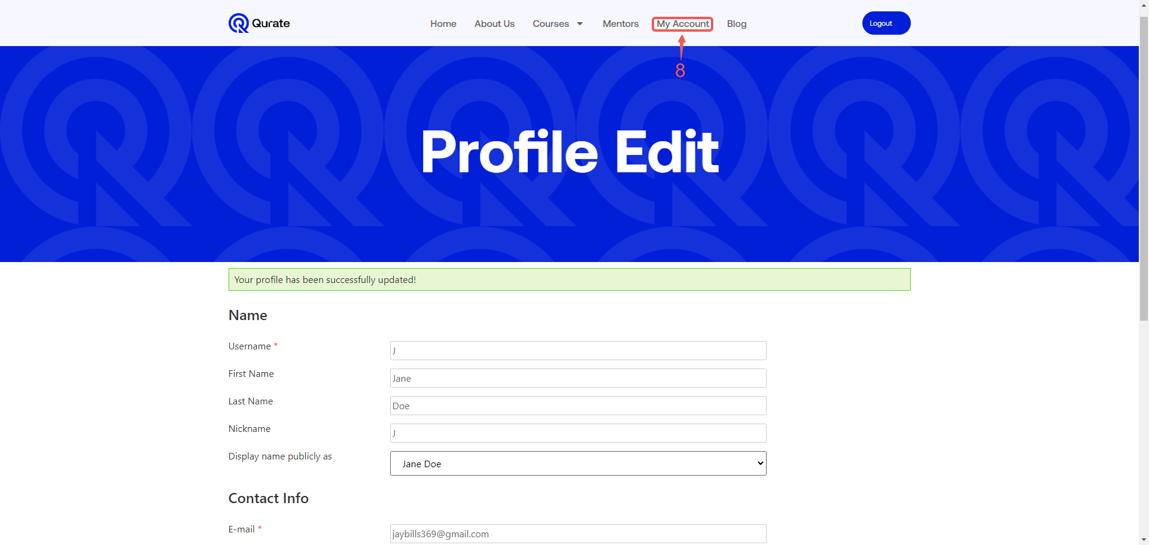

Course Content

This section serves as your one-stop shop for everything related to your enrolled course. Here, you'll find all your course materials, including lessons, access to your AI companion for support, and a convenient form to submit support tickets if you encounter any issues.

- Click on your Course name➀ to access the Course content.

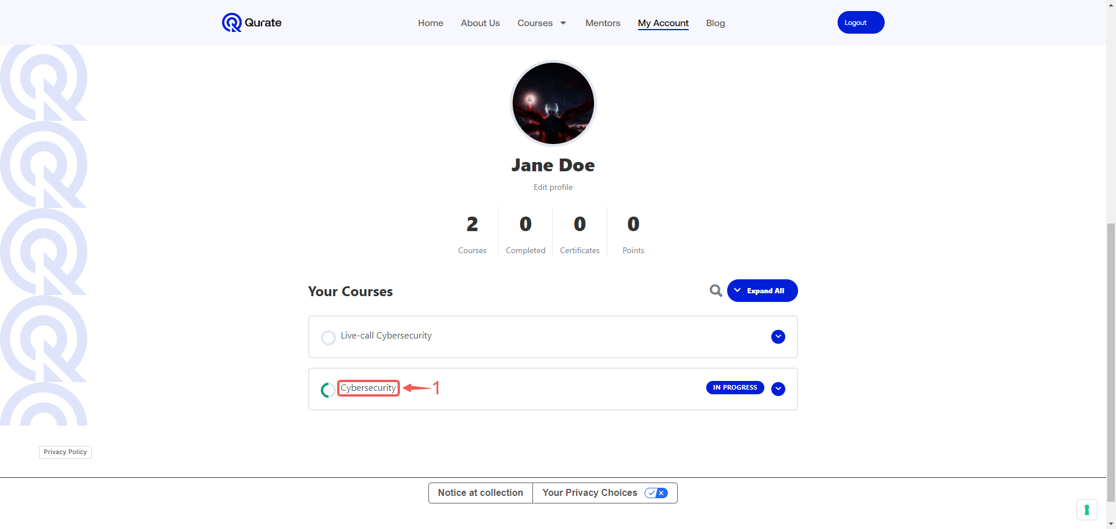
- The Student Companion segment combines two helpful resources. Here, you'll find your AI companion, a virtual assistant programmed to answer your course-related questions and offer guidance. You'll also find a dedicated student support section where you can submit tickets if you encounter any issues and require further assistance.
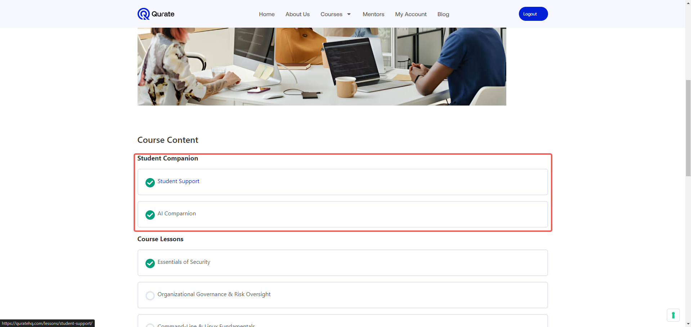

Student Support

The Student Support page serves as your channel for reporting any difficulties you encounter within the course. Feel free to submit a detailed description of your issue or ask a specific question. The support team will analyze your request and provide the necessary solution to ensure your learning progress continues smoothly.

- Click on Student Support➀.

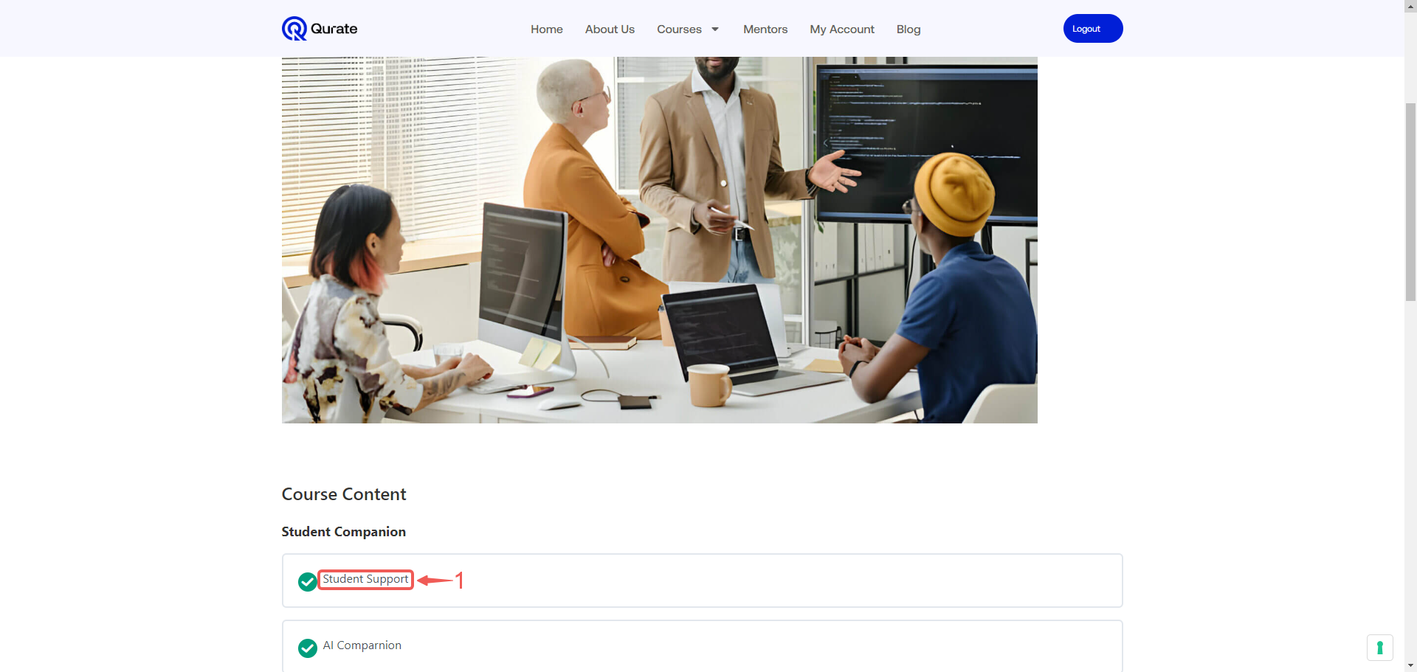
- Enter your First Name➁ and Last Name➂.

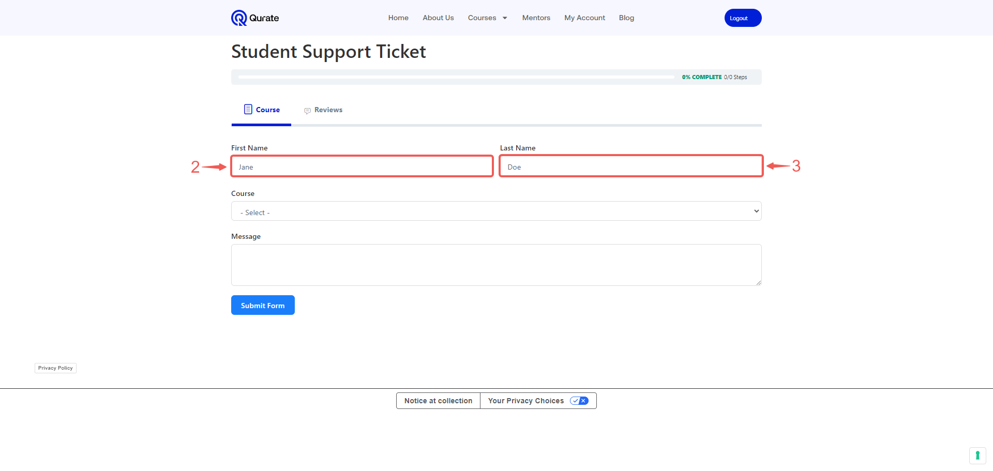

- Click on the Course➃ field to display the dropdown menu, from the menu select the Course➄ you want to access.

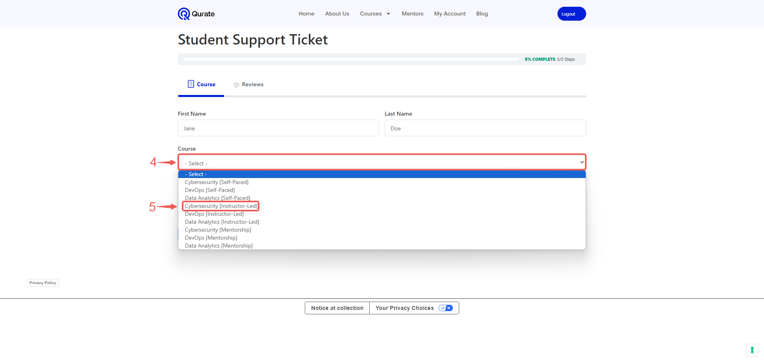

- Compose your Message➅ and click the Submit Form➆ button to log your student support ticket.

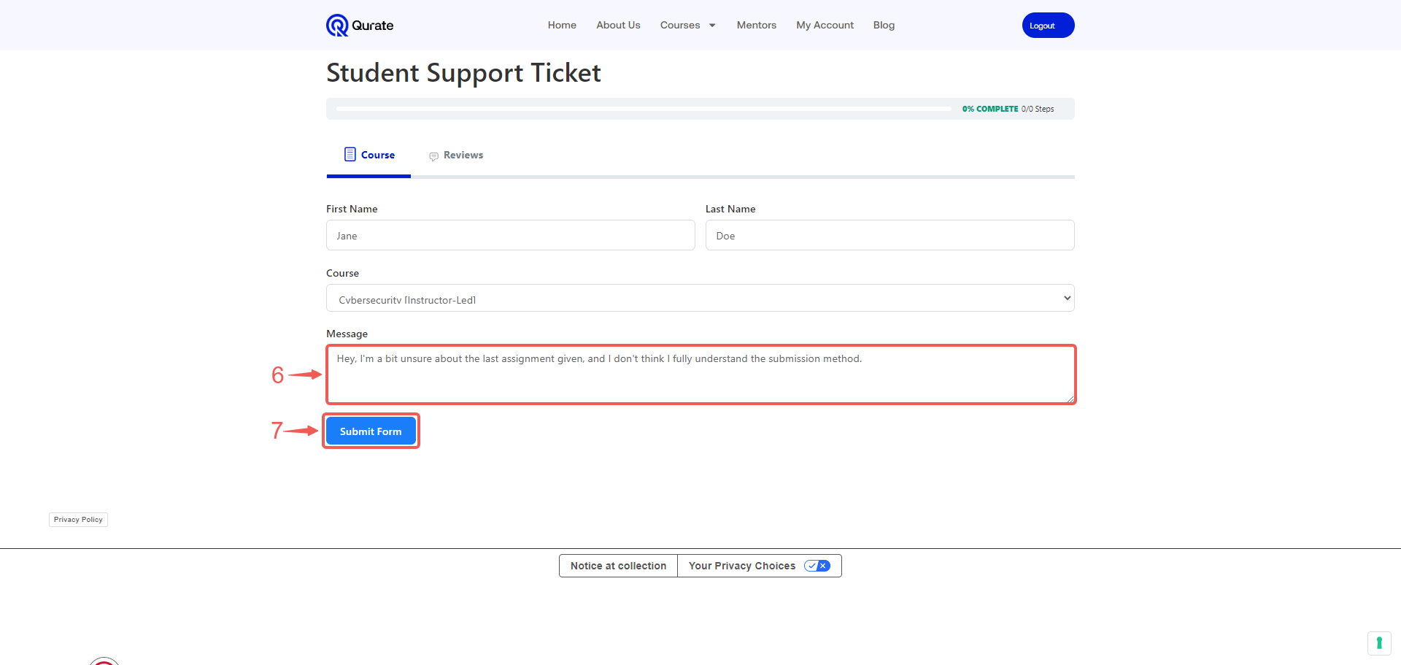

- Click Back to Course➇ to return to your course page.

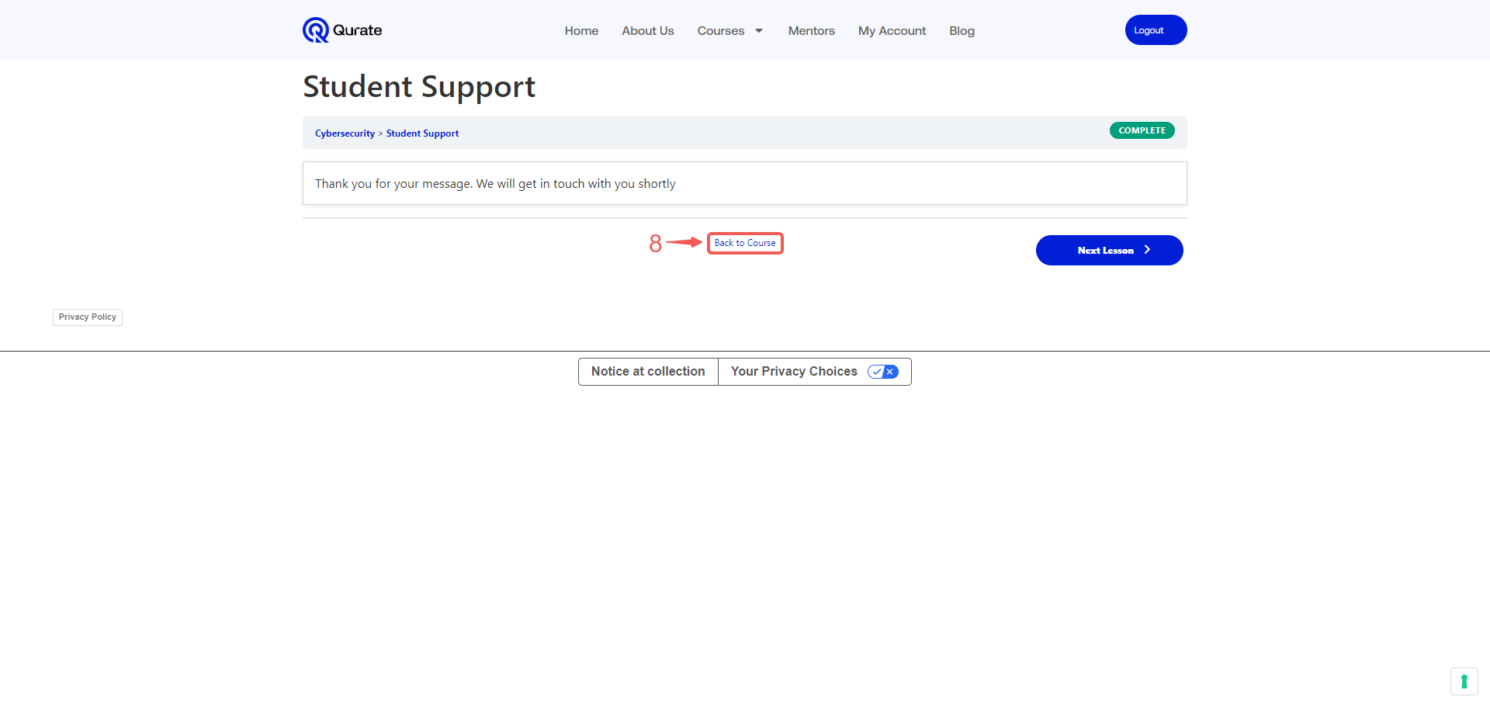

AI Companion

The AI Companion page houses your personal AI assistant, Ticha. Ticha's training enables her to simplify complex terms into more relatable forms to enhance your understanding. As your tutor, Ticha clarifies specific topics throughout your training, enhancing your learning experience.

- Click on AI Companion➀.

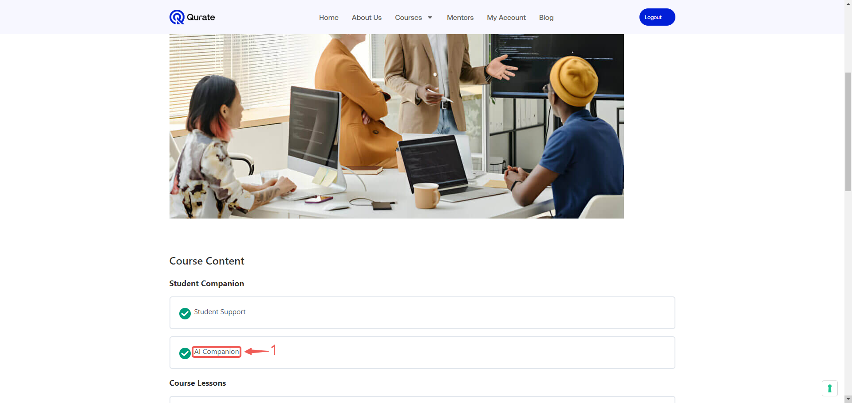

- Type the question➁ you want to ask your AI Companion, and then press Enter.

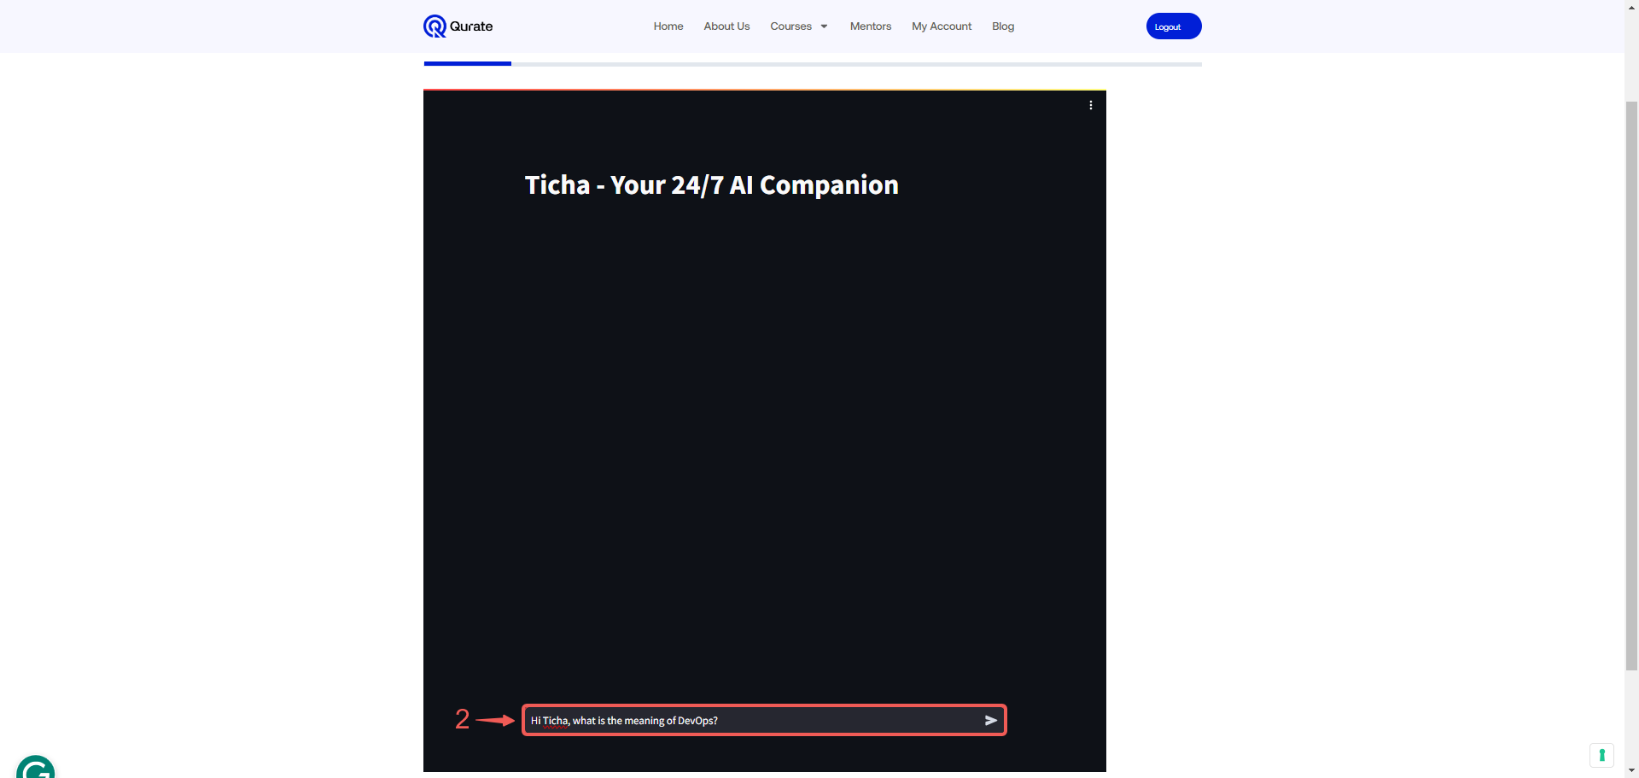

- Ticha provides answers with relatable examples for easy understanding.

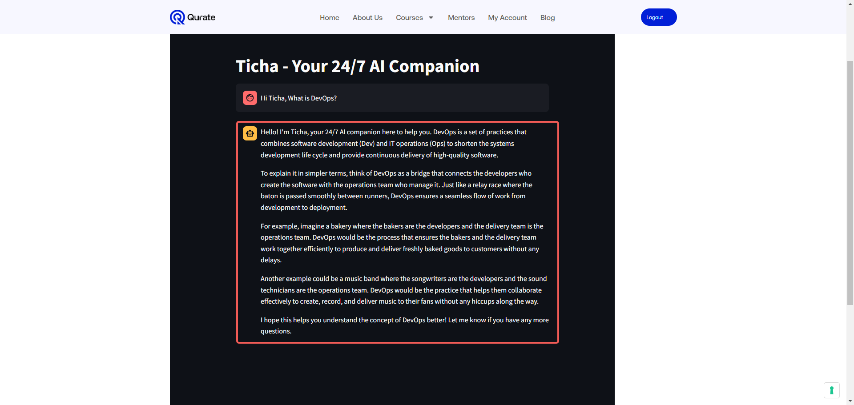

- Click Back to Course➂ to return to your course page.

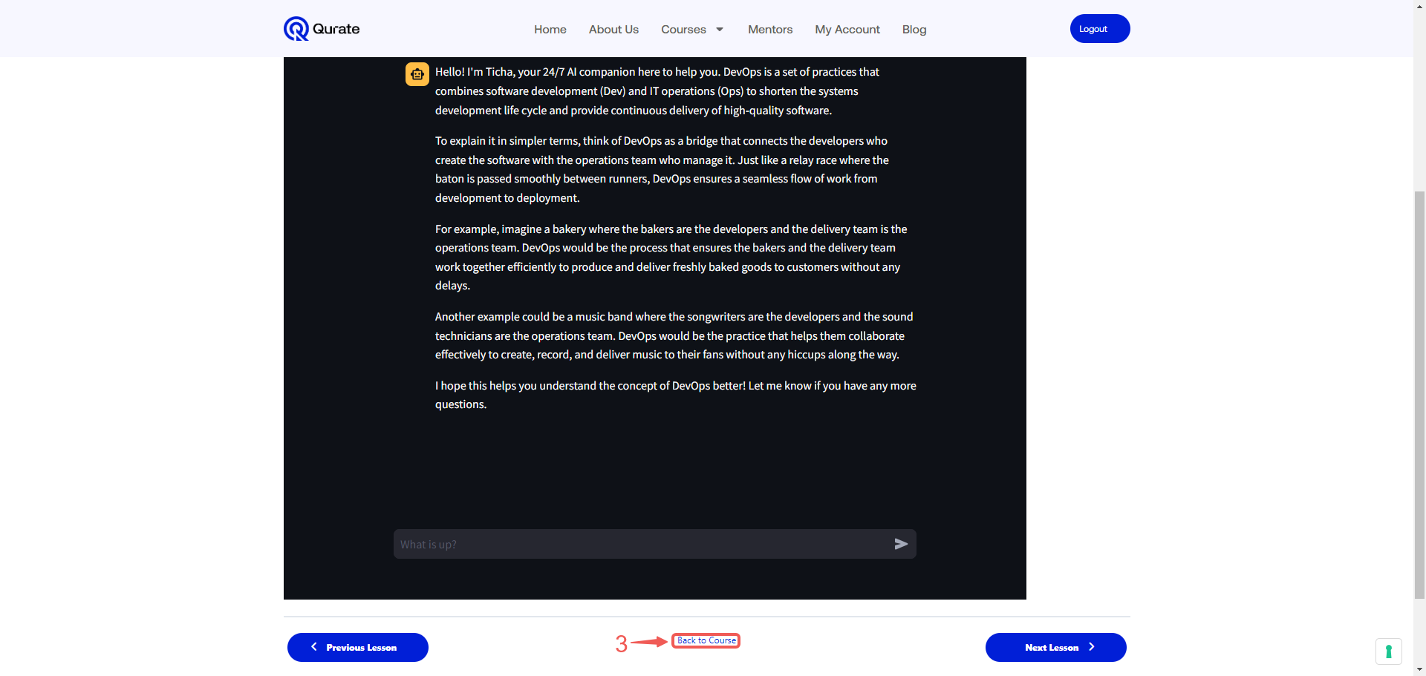

Course Lessons

This section is dedicated to your course lessons, including all prerecorded classes, assignments, and any projects the instructor will assign. Here, you can access the materials necessary for your learning journey and stay updated on your coursework.

- Scroll down to Course Lessons➀.

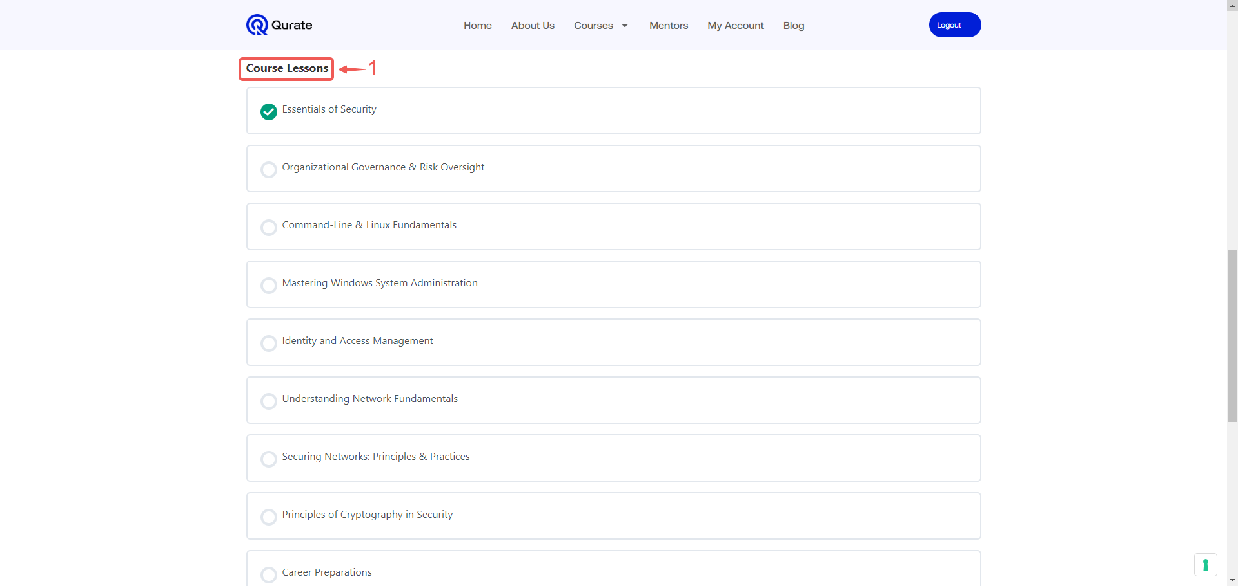

- Select the module➁ you intend to study.

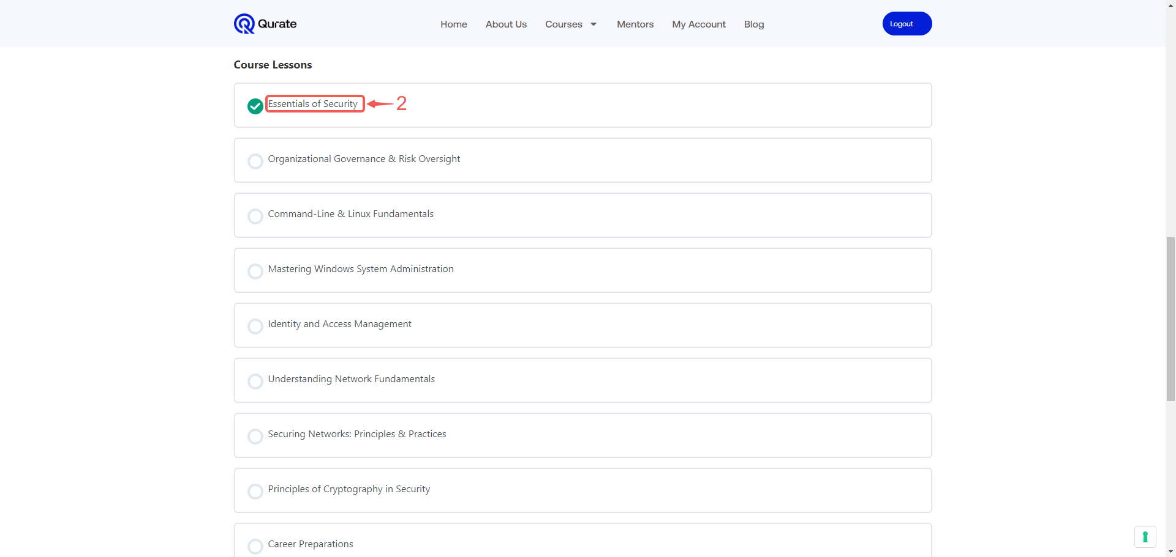

- Watch the pre-recorded video. If there is an assignment attached to the module, submit it by clicking the Browse➂ button.

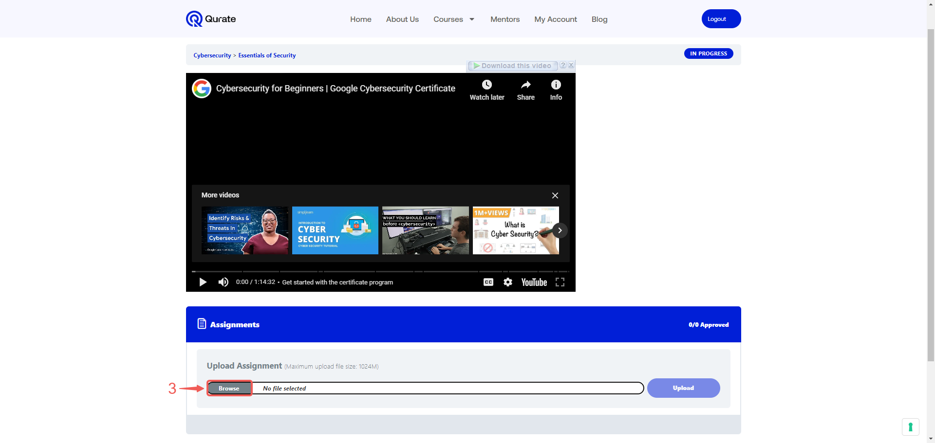

Note: Some modules do not have assignments attached; you only need to watch a video and move to the next lesson. For modules with assignments, you can choose to wait for your instructor to approve your submission before proceeding.

- Select the file➃ you wish to upload. Then, click the Open➄ button to submit it to the platform.

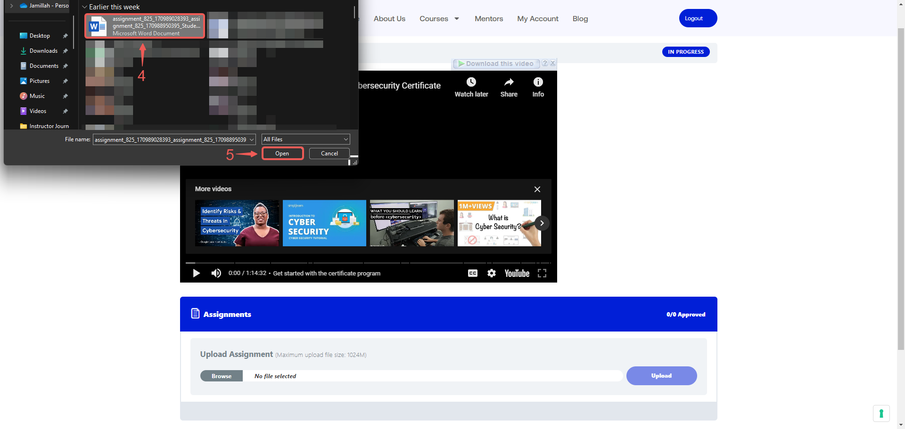

- Click the Upload➅ button to submit your assignment.

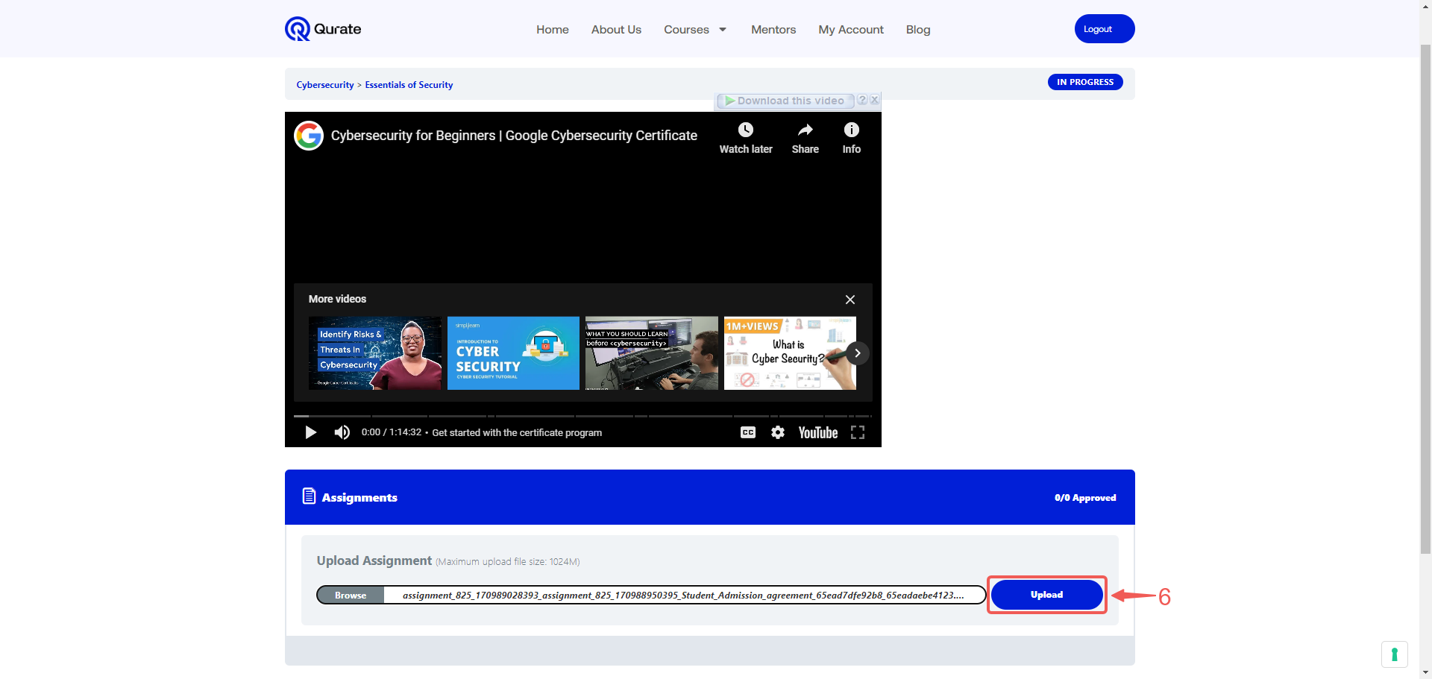

- Your assignment is awaiting approval from an instructor.

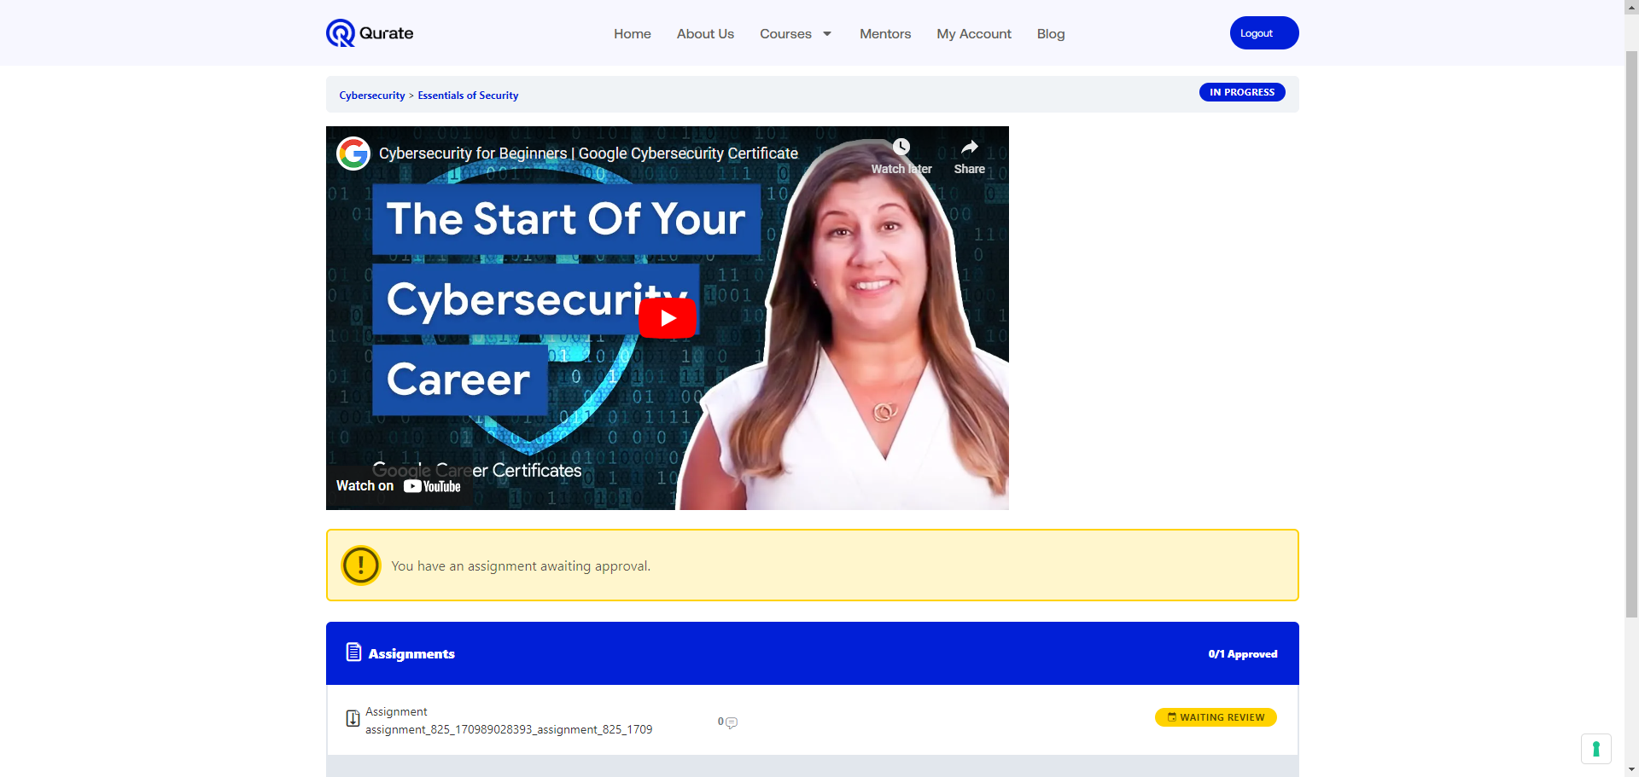

7. Once your assignment has been APPROVED➆, it will be updated in the assignment field. Additionally, the comment icon➇ will indicate if the instructor left any comments while reviewing your assignment.

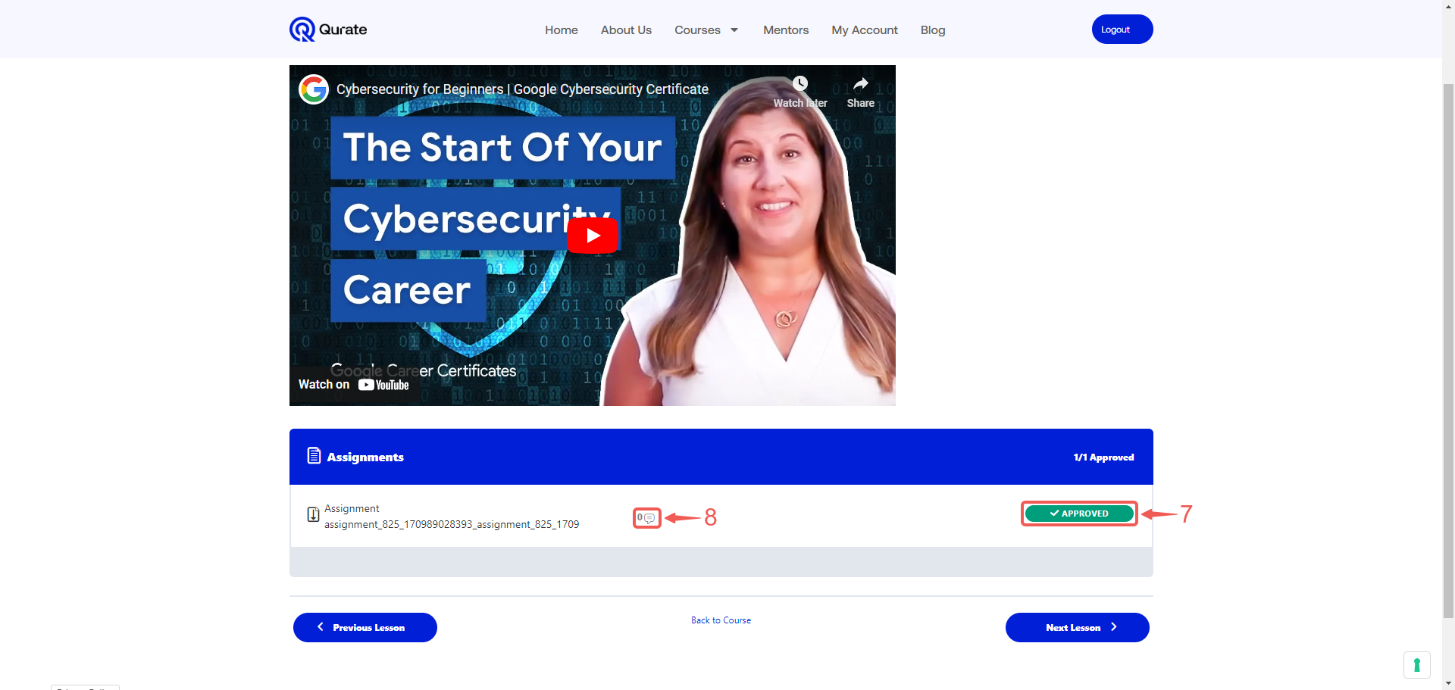

8. Once you've completed the current lesson material, click the Next Lesson➈ button to progress to the next lesson in the module. If you need to navigate back to the list of all course lessons, click Back to Course➉.

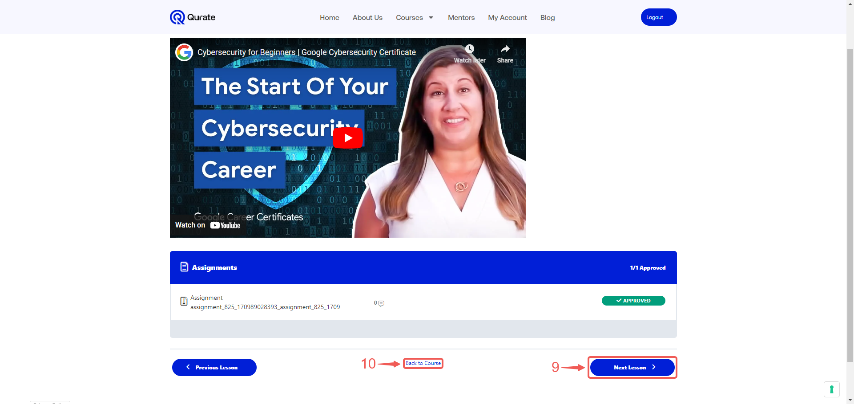

Live-class

The Live-class section is the primary location for accessing the Zoom links for your live classes. Here, you'll find the Zoom links you need to join your scheduled live classes, ensuring you stay connected and engaged with the course material and your instructor.

- Select My Account➀ to navigate back to your account page.

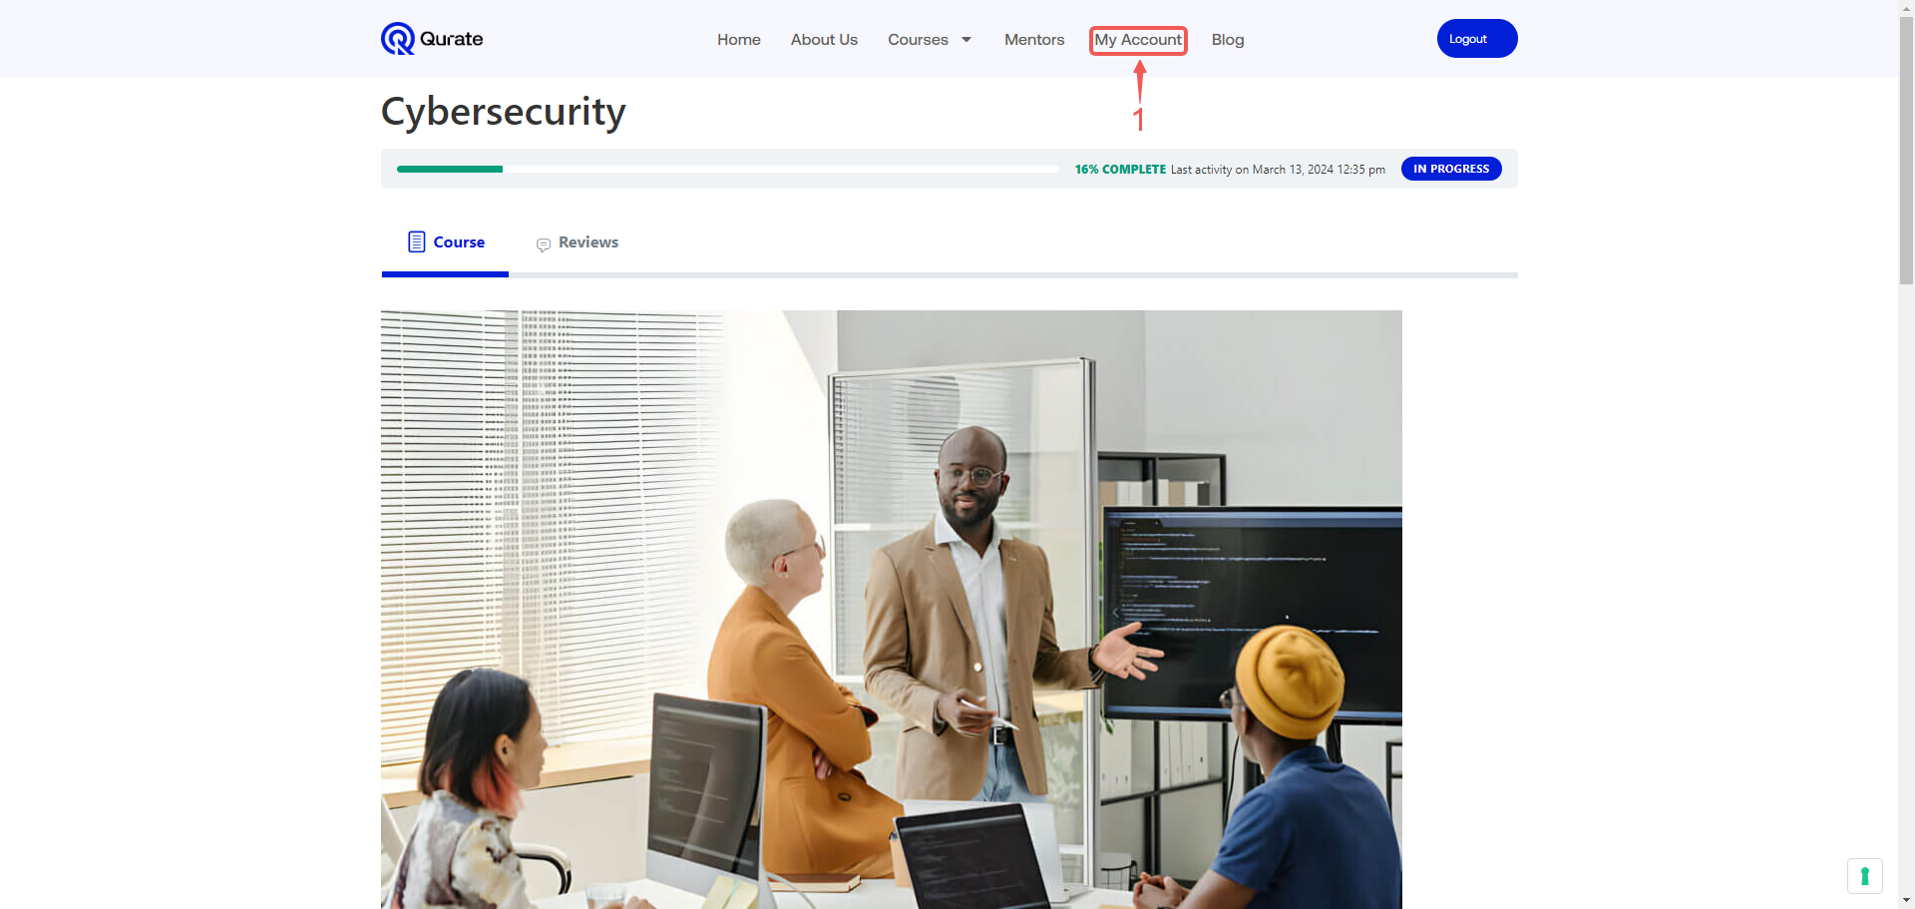

- Click on Live-call➁.

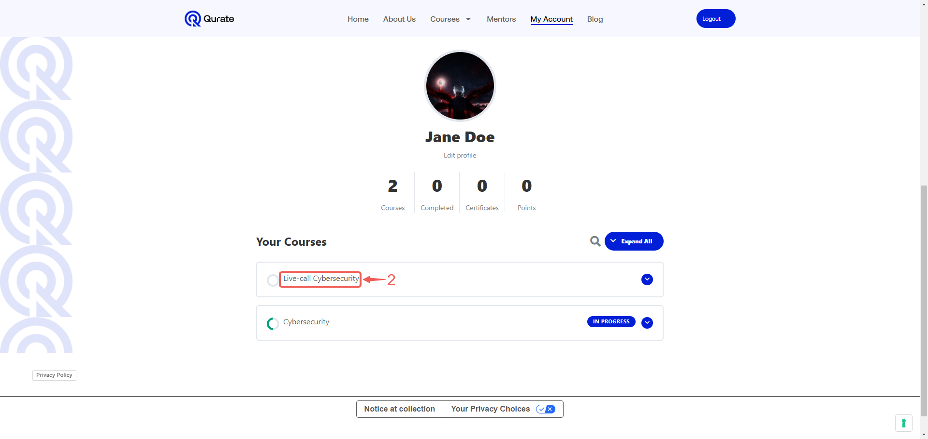
- This page offers a quick overview of your upcoming live Zoom class, including the meeting topic, start time, and its current status. This allows you to easily stay informed and prepared to join the session.

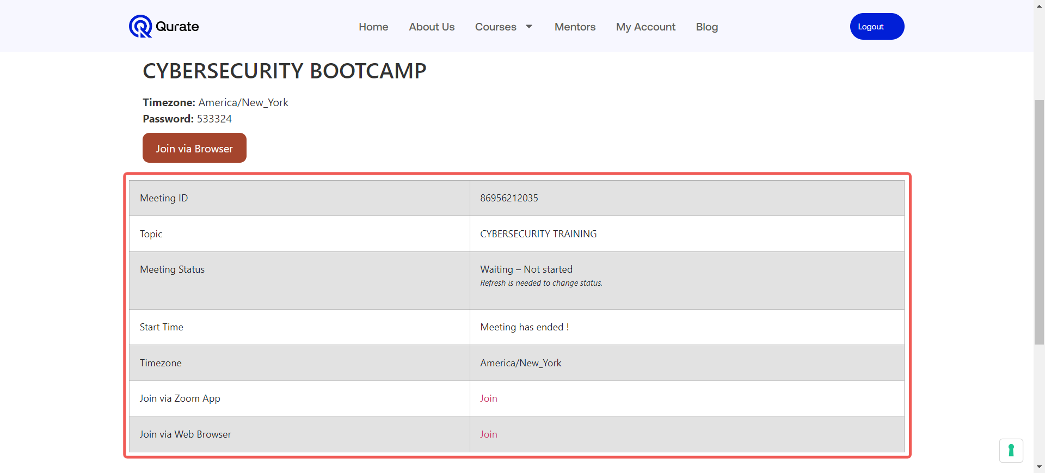

Join Classes Using the Zoom App:

- To join the meeting using the app, click the link➀ next to Join via Zoom App.

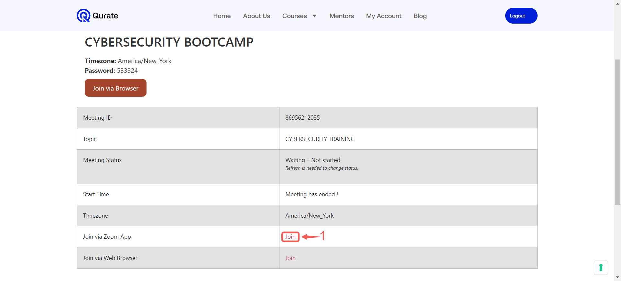

- Click on Open Zoom Meetings➁ to launch your Zoom app and access the meeting.

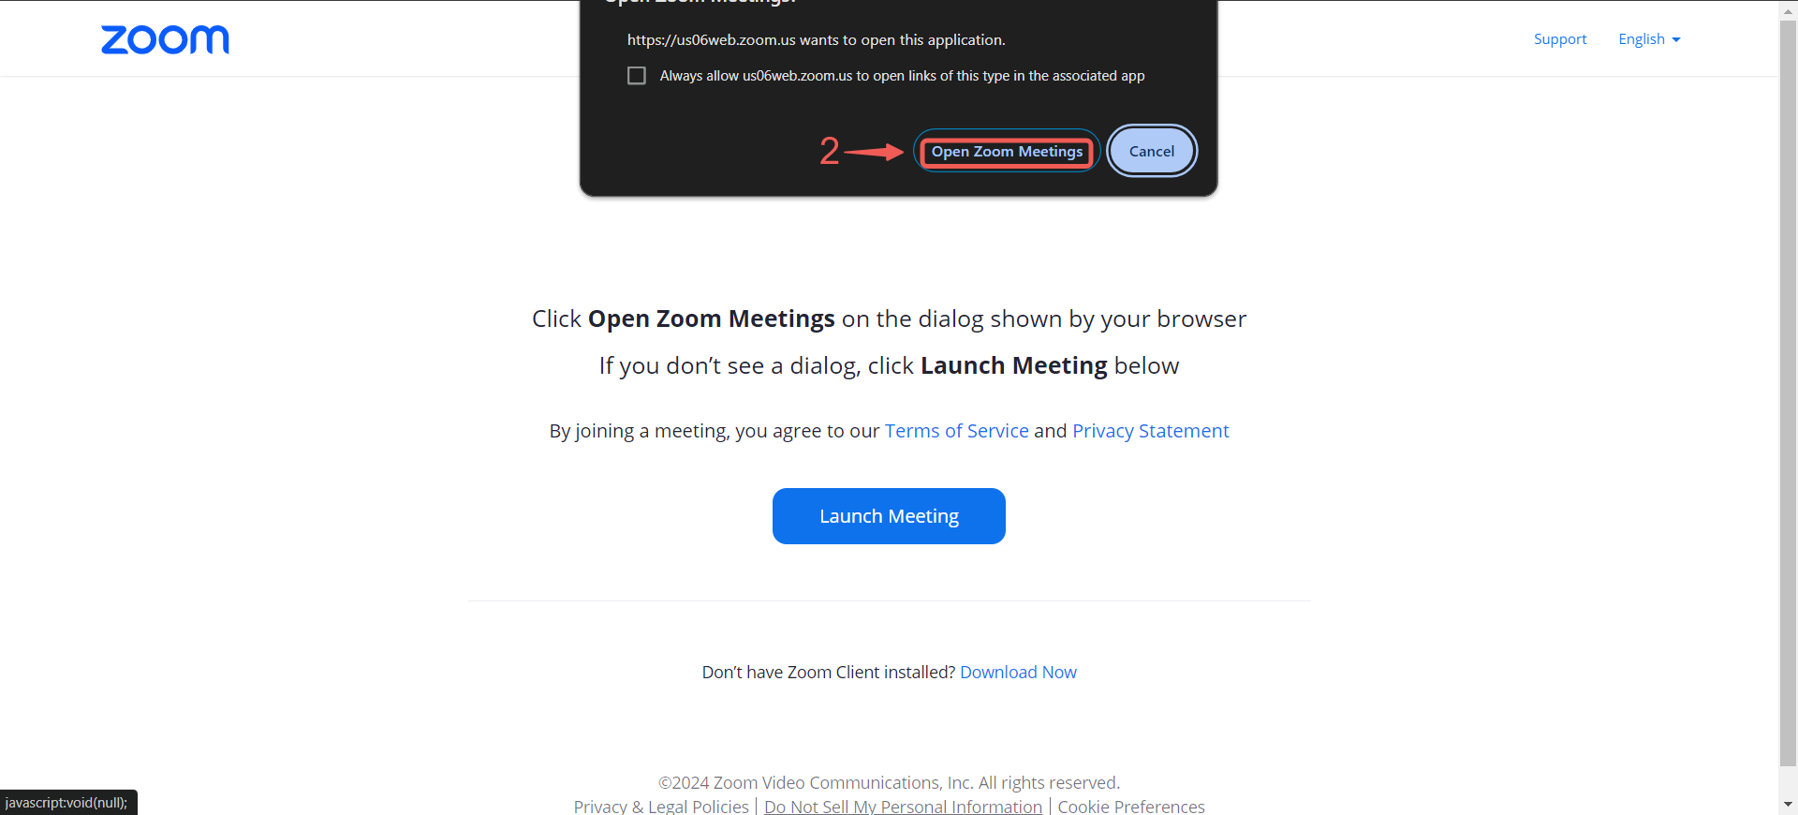

- Click the Join➂ button.

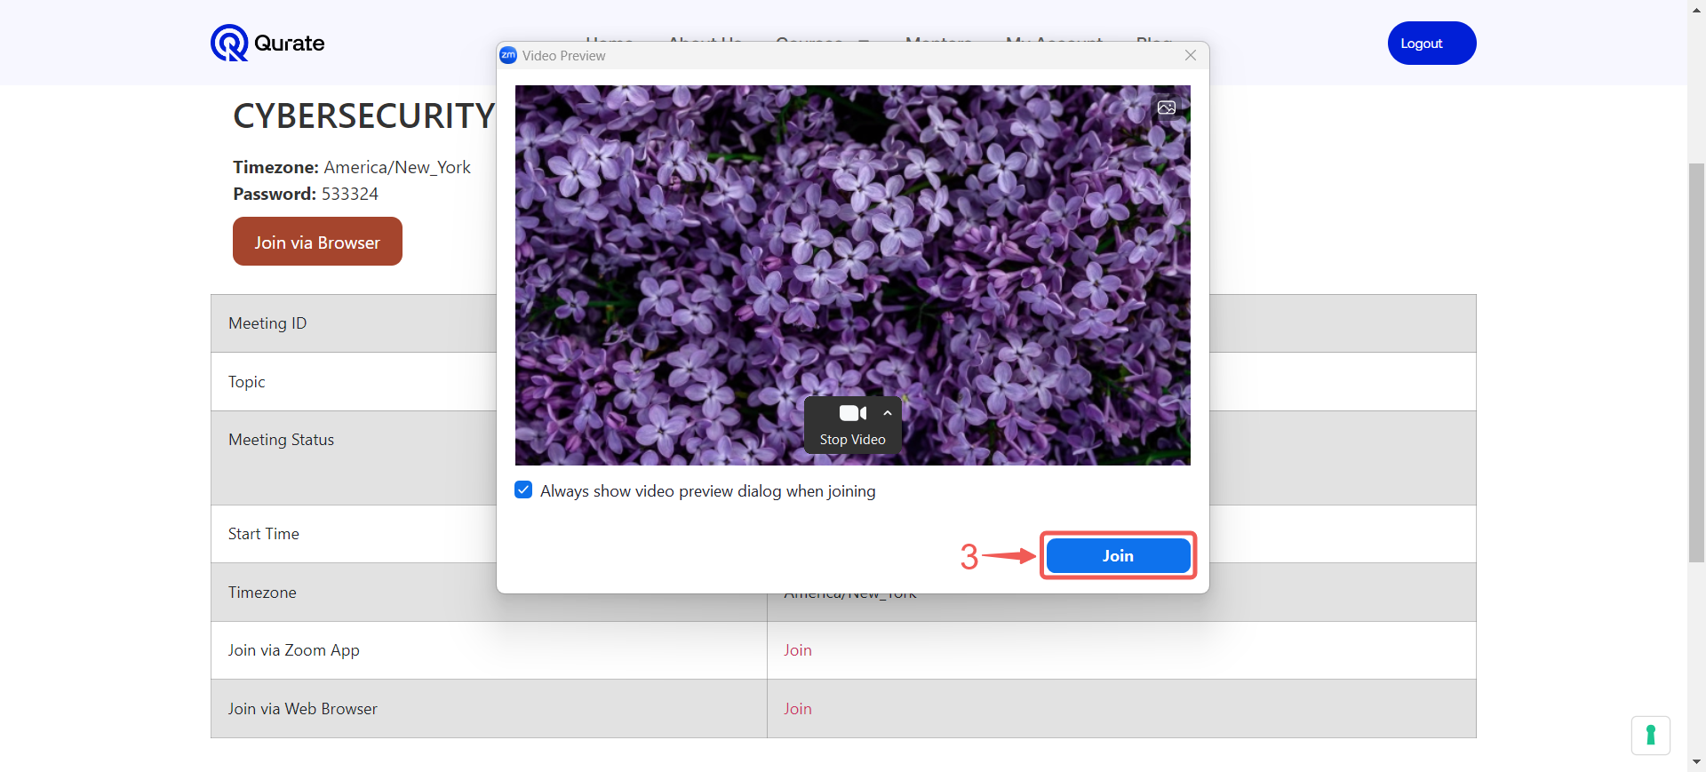

- Select Join with Computer Audio➃ to grant microphone permissions and enable you to speak during the meeting.

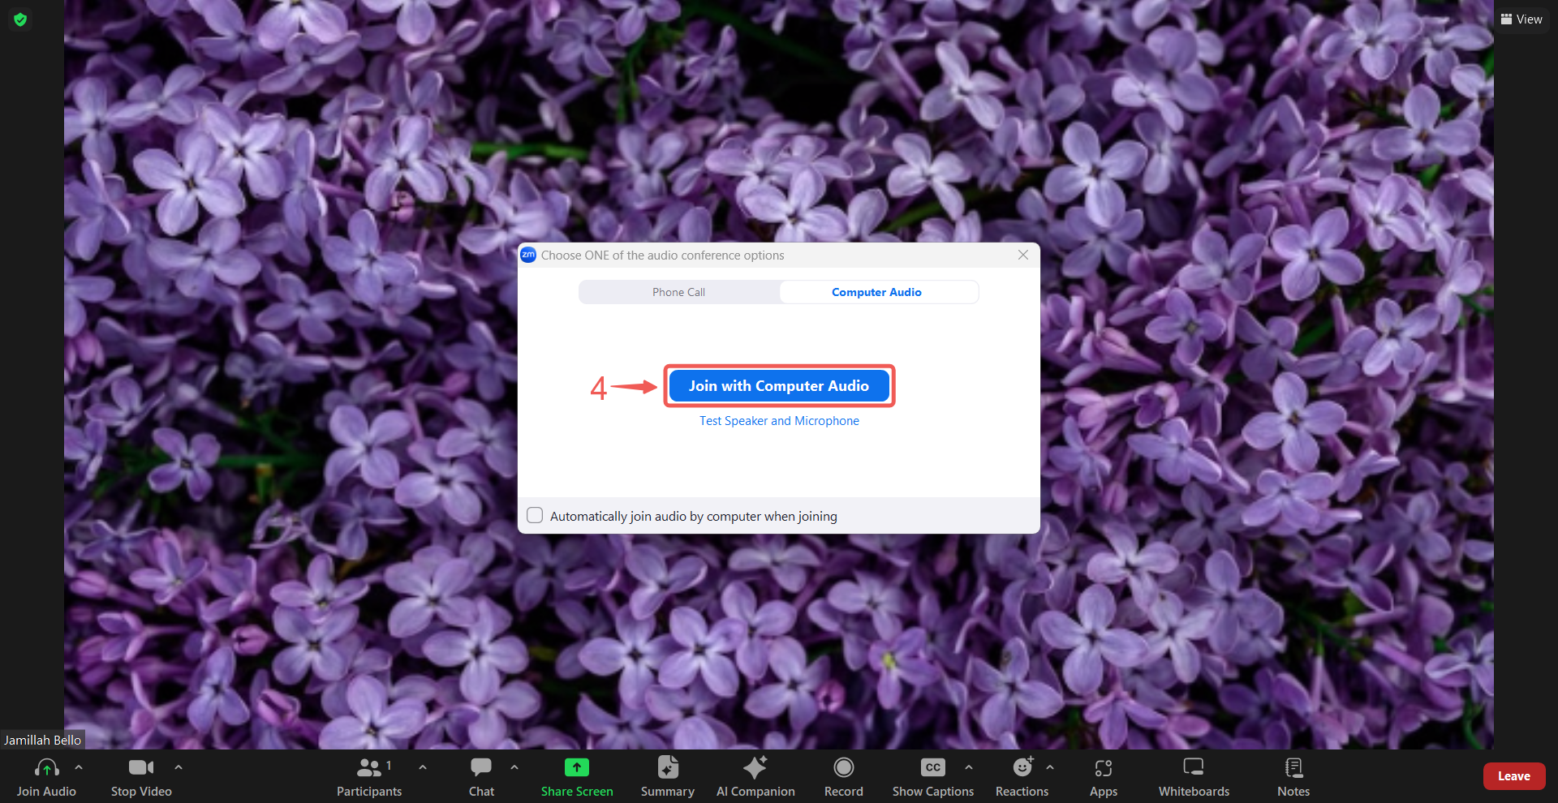

Note: You have now successfully joined the Zoom meeting to attend your live class with your designated industry expert.

- Once the live class session has ended, you can click the Leave➄ button to exit the Zoom meeting and return to your Qurate course dashboard.
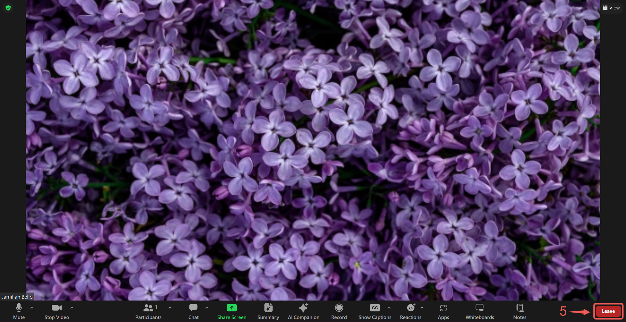

- Click on Leave Meeting➅.

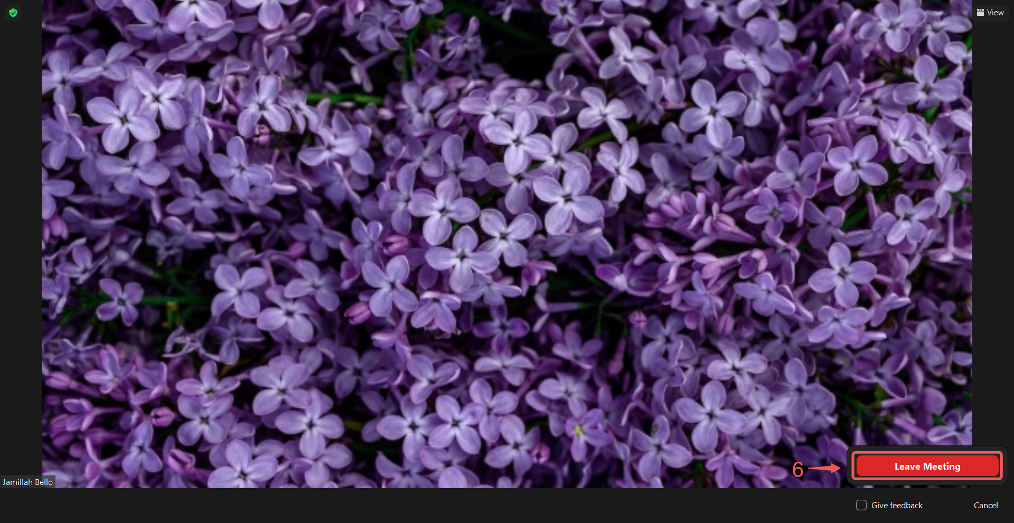

- After the meeting ends, you will be redirected to the Live-call meeting page.

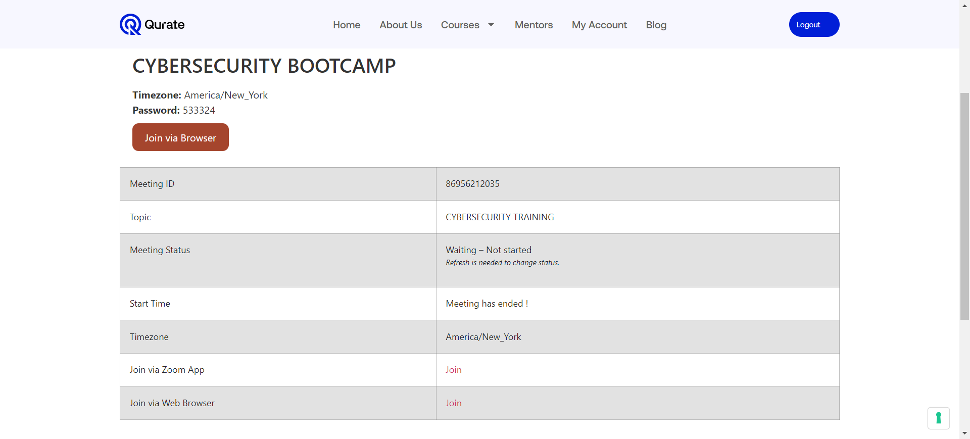

Join Classes Using Zoom via a Web Browser:

- If you don't have the Zoom app installed and wish to join the meeting using a web browser, click the link➀ next to Join via Web Browser.

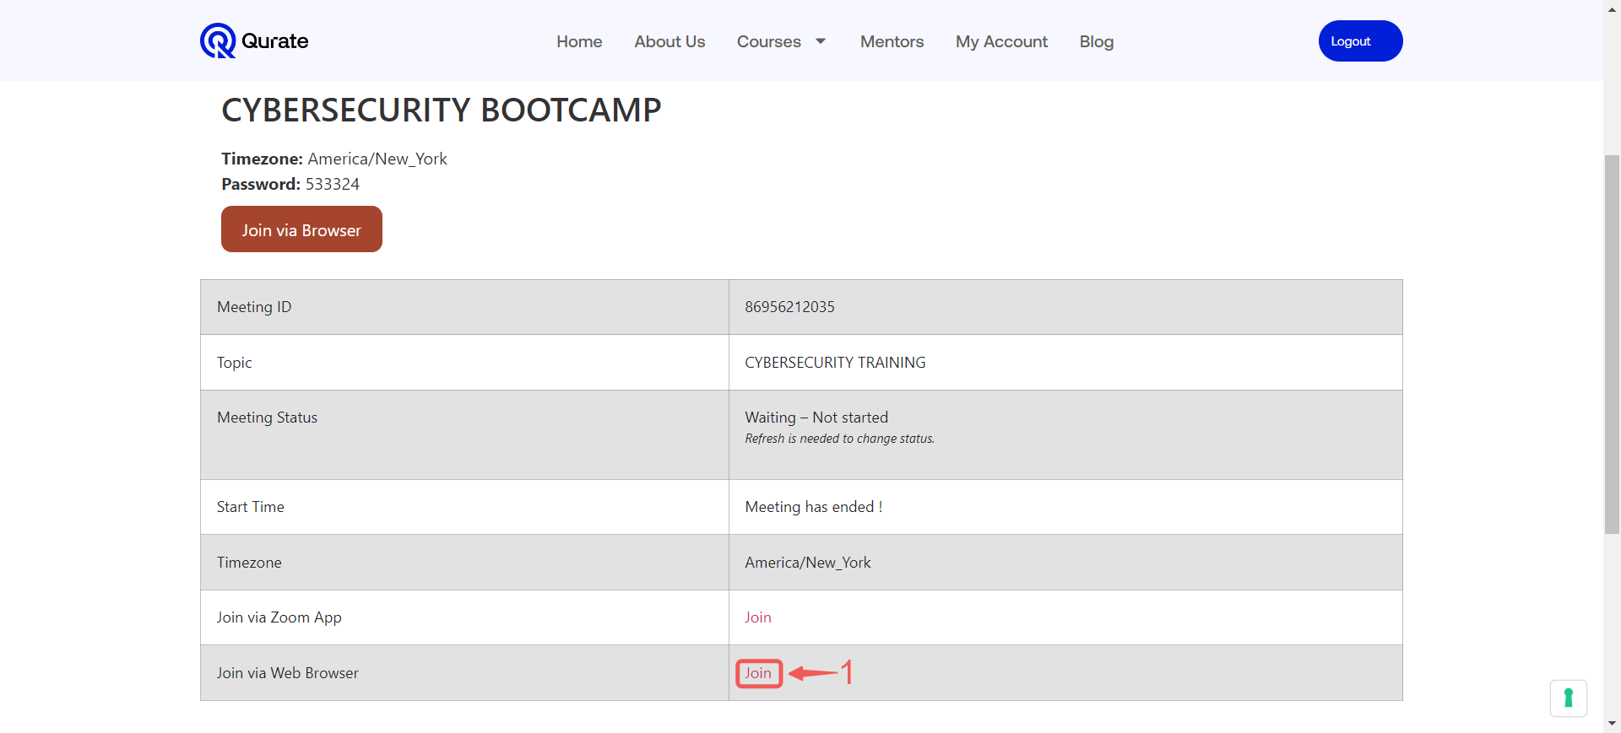

- Click on the Join Event via Browser➁ button.

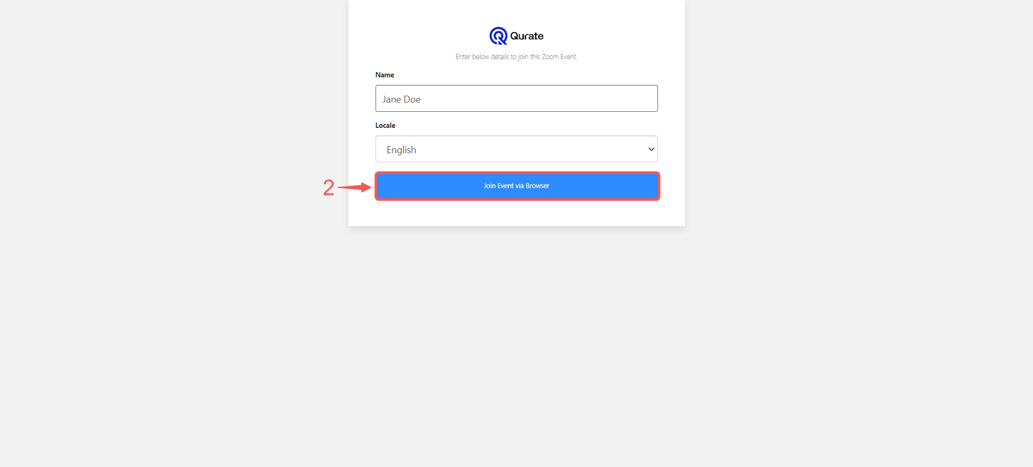

- Select the meeting name➂.

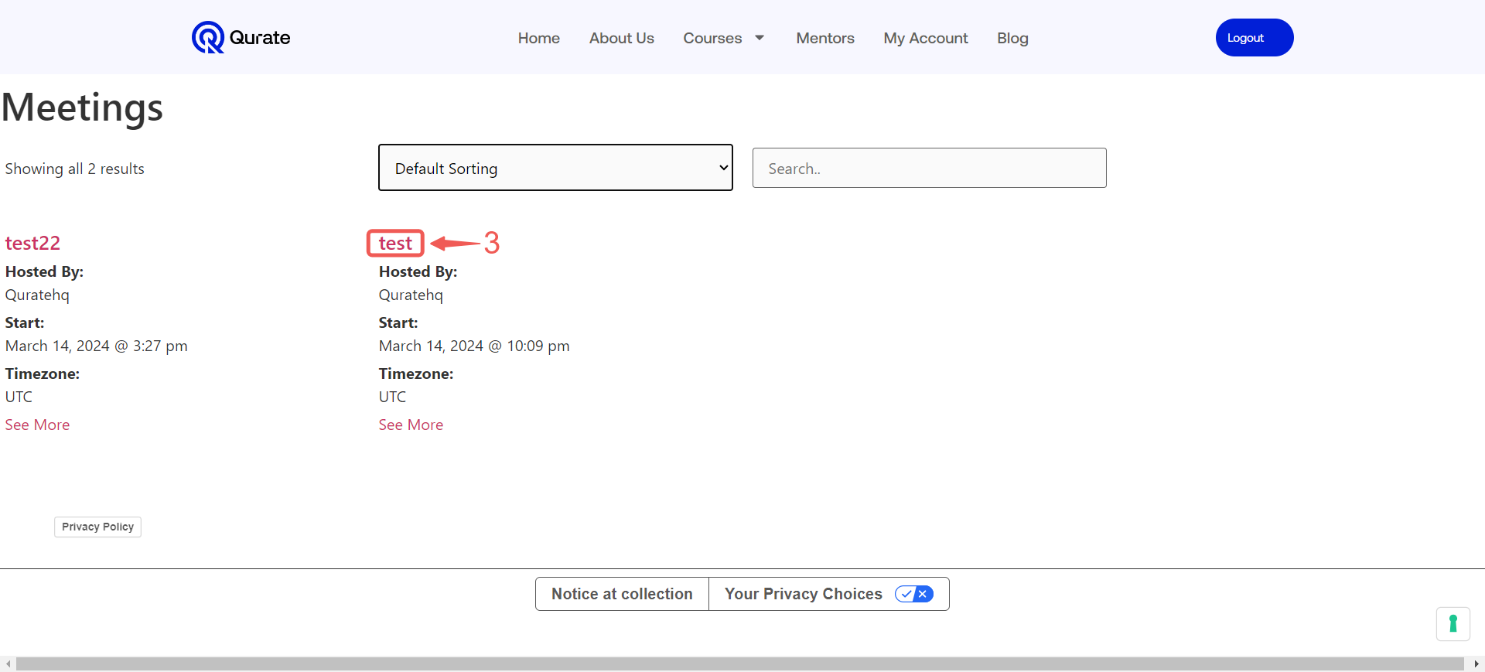

Note: Please ensure you review the meeting details on the Live-call page, which includes all meeting information and the meeting time, to ensure you are joining the correct meeting.

- You will be directed to your live class.

This concludes our guide to navigating the Qurate student platform! We hope this information equips you with the knowledge to confidently access course materials, utilize the AI companion, and participate in live classes. We encourage you to explore the platform further and leverage all the resources available to optimize your learning experience.

